Level 2 Awareness Course
Trainer Handbook

Duration: 2.5 hours – 09:30 to 12:00 hours

This training is for staff and volunteers who work with adults and/or informal carers on a one-off basis or infrequently.

It is offered via OSAB as multi-agency training and is delivered via our pool of trainers from agencies who work in the field of adult safeguarding.

Level 2 Awareness training is valid for up to 3 years.

Target audience:

For all those who work with adults and/or carers as part of their work, be it paid or voluntary, for example; maintenance technicians, administrators, customer service advisors, leisure centre staff, voluntary drivers etc.

OSAB Contact:
Helen Kershaw, Learning & Engagement Officer
07747 008 359
Helen.kershaw@oxfordshire.gov.uk please also cc to osab@oxfordshire.gov.uk

Contents Page

Slide Title | Page Number | Estimated Minutes/Time
Title Page | 3
Welcome & Housekeeping | 3/4 | 5 mins / 9:30 – 9:35
Our Training Agreement | 4/5
Aims & Objectives | 5
Introduction & Networking | 6 | 5 mins / 9:35 – 9:40
How does adult safeguarding differ from children’s safeguarding? | 7 | 5 mins / 9:40 – 9:45
What does ‘safeguarding’ mean? | 8
What is abuse? Where can it take place? Who can be an abuser? | 9 | 5 mins / 9:45 – 9:50
Why we’re here: Legal framework | 10
Who does adult safeguarding apply to? | 11 | 10 mins / 9:50 – 10:00
Safeguarding the wider population | 12
Categories of abuse | 13 & 14 | 30 mins / 10:00 – 10:30
What to look out for | 15 & 16
BREAK | 17 | 5-10 mins / 10:30 – 10:40
Case study | 17/18 | 5 mins / 10:40 – 10:45
Six Principles : Safeguarding Adults | 18/19 | 10 mins / 10:45 – 10:55
Communication | 19/20
Decision Making in Practice | 20/21 | 5 mins / 10:55 – 11:00
Independent Advocates | 21/22
What to do with a safeguarding issue? | 23 | 15 mins / 11:00 – 11:15
Record keeping | 24
Safeguarding Adults Service | 25
Case studies | 26 | 40 mins / 11:15 – 11:55
Summary | 26 & 27 | 5 mins / 11:55 – 12:00

Trainer’s note:

For every session you deliver, please arrive in plenty of time to set up laptops, screens etc., and to ensure that everything is working before the session starts.

Not every venue sets out tables as we ask. It will be you and your co-Trainer’s decision as to whether you wish to move tables and chairs into a different arrangement than you found it. There is no expectation from OSAB that you will do this.

Not every venue has refreshment facilities. This has been explained in the confirmation email that goes out to people who register for training, with a request that they bring their own refreshments if they require them.
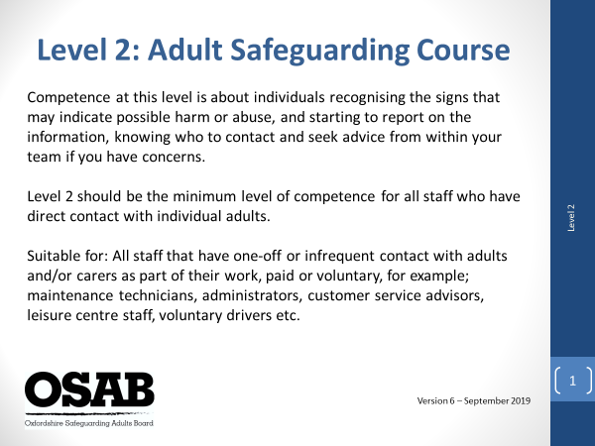

This slide explains the level of the course and who would benefit from attending.
No explanation is required. Have this slide showing as people come into the room, prior to the start of the session.

When ready to start, it is worth just checking that everyone is expecting to attend Level 2 Awareness (Adult Safeguarding) training, as opposed to anything else!

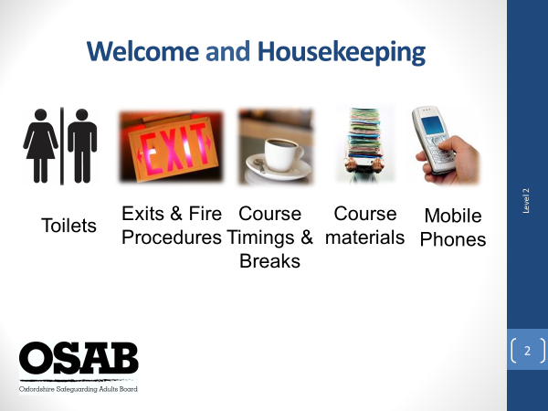

Please ensure you know where toilets and fire exits are located, whether any ‘tests’ are due in terms of fire drills etc., and where you would need to congregate if an alarm goes off.
Course timings – 2.5 hours in length, a break of 10 minutes. If anyone needs a comfort break of any kind during the session they are free to do so and do not have to ask Trainers!
Course materials – the joining email will have stated copies of slides and further information will be sent after the course today, but please remind people of that.
NOTE: Please ensure everyone has signed the register as they will be marked as not attending if they do not.
Mobile phones: Switched to vibrate or silent. If anyone needs to take a call, please ask them to leave the training room to do so and return to the session if they are able to. NOTE: Please ask people not to sit on phones checking their social media accounts. They will be ‘called out’ if they do!

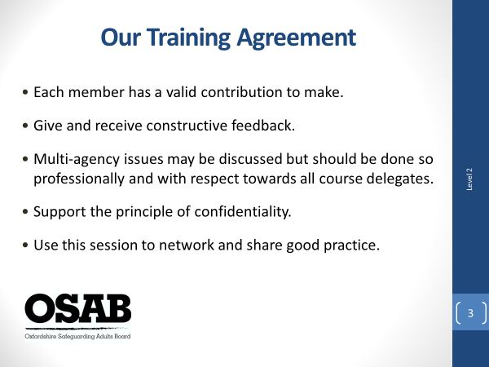

Key points:
Encourage participation by all as it makes for a more enjoyable and memorable training experience. It may be useful to explain that training in a multi-agency environment better assists people to gain understanding of different perspectives, and professional expertise.

Referring to each member has a valid contribution
Explain that safeguarding adults is about sharing information and working together. For example, some agencies/workers will be involved with an adult only at the point of crisis, and others may have long standing relationships with adults before safeguarding issues are raised. All professionals/workers and individuals are important, and only by working together do we see good practice and outcomes for adults.

Learning is about participation and positivity
As safeguarding is everyone’s responsibility, it is useful to mention that it is about workers feeling confident about safeguarding and this course aims to ensure that a difficult subject is considered with sensitivity and positivity. NOTE: this really depends on your training style, but effective learning should be fun and not restrictive in its message.

Encourage people to ask for clarifications and question when they don’t understand or don’t agree. Remind people that participants will have a varying degree of experience in safeguarding and any challenge should be respectful.

Trainers should ask delegates to be mindful of jargon and to explain any abbreviations.

Multi-agency issues may be discussed but should be done so professionally…
Sensitivity and support for each other is important both in group training and at work. Personal backgrounds and experiences will be varied and all have different valuable perspectives to draw upon. Any agency barriers that arise will be addressed; however, all delegates must be made to feel welcome and at no stage should be a ‘target’ for any agency barriers. Delegates should also be asked to be sensitive in how points are made when discussing other agencies.

Support the principality of confidentiality
Remember to speak about confidentiality. Discussion within the group is confidential unless the Trainer deems there has been a disclosure that puts an adult/adults, the delegate/professional or the Trainer at risk. In this cases the Trainer has an obligation to report it.

Identify that it is likely that real cases may be utilised but confidentiality should be maintained; therefore, no names, colleagues or clients details should be mentioned. Real cases are used to help make training more realistic and to help focus on certain elements. Members may recognise some of the information used and should they at any stage feel aspects are not being correctly represented, they should speak to the Trainers.

REMEMBER: this course covers some very emotive areas so remind delegates that if they’re struggling with any issues the course raises, they can take time out or speak to the Trainer during a break/at the end of the course.

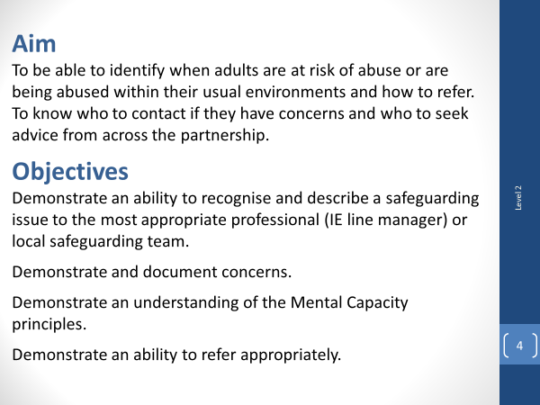

Ask delegates to view the aim and objectives of the training and check that people are happy with the course overview.

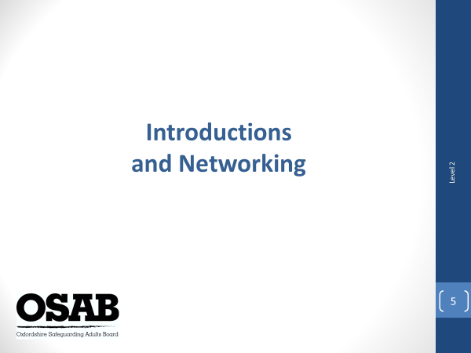

Trainers should describe their own role and the organisations they work for. This helps to establish their credibility as someone to present on safeguarding (don’t forget add-ons to your role such as being a Best Interest Assessor, AMHP etc.)

Next ask the delegates to introduce themselves to the whole group. It would be good to hear their name (doesn’t have to be full name), what their job role is and which organisation they work for (no acronyms please), along with a brief explanation of the people they work with/type of work they do.

It is here that it is useful highlight how networking with each other helps us to gain an understanding what support is available for people. Connections and information can at times make all the difference.

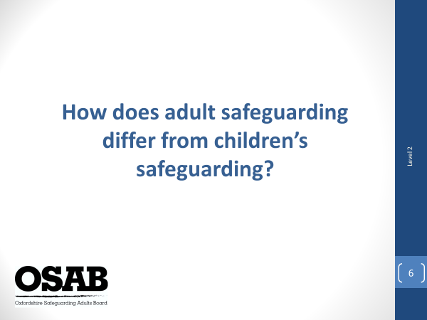

Trainers should ask delegates in small groups to discuss this point for a couple of minutes and then feedback to the group.

Trainers to confirm or challenge answers given.

The reason for this slide is that some attendees may work with both children and adults, so may have undertaken children’s safeguarding training, and may believe adult safeguarding is the same as children’s. It is not.

- Children and adults may each face a different set of issues within the same environment.
- Definitions and terms used differ.
- Procedures for reporting abuse and handling cases are not the same.
- There is different legislation and policy.

One important difference between safeguarding adults and safeguarding children is an adult’s right to self-determination. Adults may choose not to act at all to protect themselves, and it is only in extreme circumstances that the law intervenes. This will often only happen when an adult is assessed to lack capacity in that area, or where the concerns may extend to children, such as when they are living in the same household. This can make the matter of safeguarding adults even more complex.

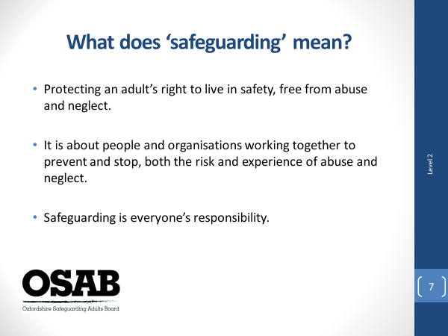

NOTE: This slide starts with the heading question only. You will need to click three more times to get the rest of the information up on the slide.

Refer back to the previous slide and remind everyone that the focus of today’s session is on adults, although consideration should always be given if children are likely to be affected by any concerns about an adult.

Trainers to ask the group to answer the question. No need to split into groups, just ask people to call out. Trainers to confirm, or challenge answers given.

Acknowledge that safeguarding is everyone’s responsibility, no matter what job role you hold within your organisation and no matter how brief your contact with a person may be.

Safeguarding covers many aspects including; recognising possible signs of abuse; reporting suspected abuse, to investigating, and supporting people who have been abused. The amount you need to know, or do, will depend upon the remit of your role.

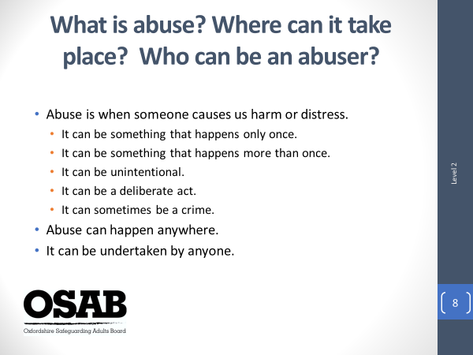

NOTE: This slide only shows the heading questions initially. Once feedback gained from the group, you will need to click the slide four more times in order to get all information on the slide, i.e. click once then answer each question, or click four times and answer all the questions at once.

Trainers to ask people to consider in small groups the questions for a minute.

What is abuse?

abuse
verb /əˈbjuːz/
- use (something) to bad effect or for a bad purpose; misuse.
"the judge abused his power by imposing the fines"
- treat with cruelty or violence, especially regularly or repeatedly.
"riders who abuse their horses should be prosecuted"

Other answers on the slides. Trainers to confirm or challenge responses given.

Trainers to elaborate further on the answers given on the slide if they wish, but they can also just read out from the slide as it is self-explanatory.

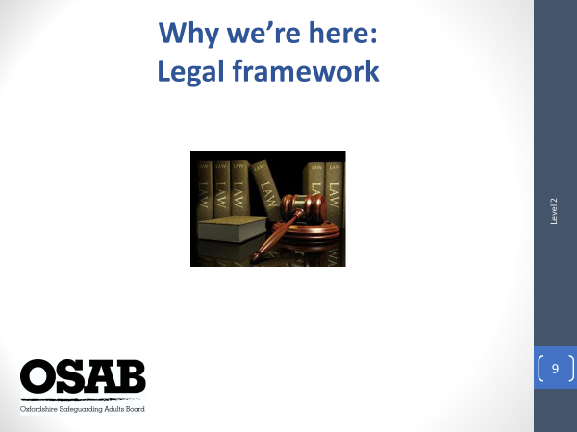

NOTE: This is a quick slide! The purpose of it is to make professionals aware that there is a legal framework in which we all operate within safeguarding work.

Safeguarding is covered by several laws, which depending upon a person’s role, they should be aware of.

Inform that adult safeguarding has no centralised set of laws for all scenarios.

It is important people receive training to understand any particular legal requirements that apply to them in their role.

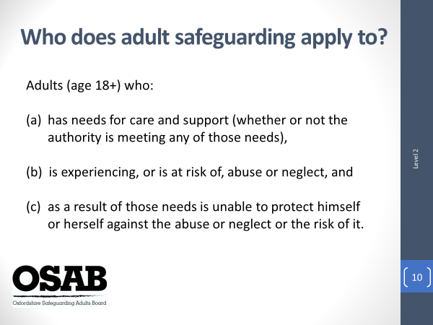

One of the most significant pieces of legislation is the Care Act 2014, which has specific sections that refer to adult safeguarding.

NOTE: the specific wording on the slide is taken directly from Section 42 of the Care Act 2014 which refers to a Local Authority’s duty to carry out safeguarding enquiries where… (read from slide)

Safeguarding work is relevant though to many other adults who do not necessary fit into the definition above, but not every adult in our community. For these people it is likely the organisations people in the room work for will therefore be highlighting safeguarding concerns and potentially working with the person and others to reduce risks (where possible), as opposed to the Local Authority (Adult Social Care)

We will consider what can make a person more vulnerable to abuse later.

NOTE: it is worth pointing out here that it is for the Local Authority to assess and make the decision as to whether a person has ‘care and support needs. Attendees will not necessarily know this themselves, but if they need to make a referral to the Local Authority, the more information they can offer in terms of difficulties a person faces, should help the Local Authority with this consideration.

Care and support are the mixture of practical, financial and emotional support for adults who need extra help to manage their lives and be independent - including older people, people with a disability or long-term illness, people with mental health difficulties, and carers.

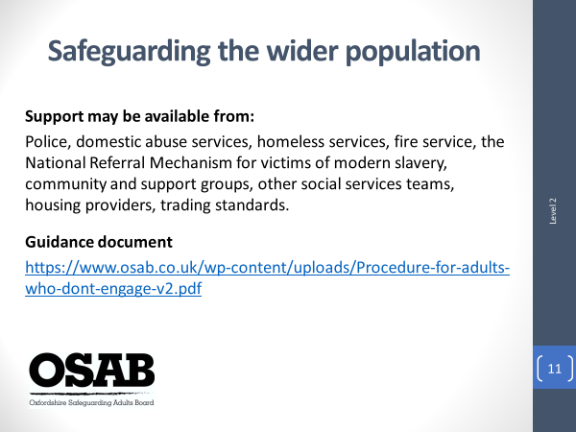

Who are the ‘wider population’? It may include; informal carers, many people who self-neglect, homeless people, and survivors of domestic abuse. Wherever someone is being harmed, or is at risk of harm, there are agencies that can help.

Trainers to acknowledge the challenges faced by many organisations of how to support people who are at increased risk of abuse, but who do not have care and support needs (so a formal safeguarding response is not triggered with the Local Authority). Partnership working is key to supporting people to reduce or remove risks they face.

There is a guidance document available on the OSAB website (link on the slide) which should be used to assist when a formal safeguarding response from the Local Authority is not appropriate. It is designed to support organisations to work in partnership to consider the risks and interventions that are appropriate for the person and their circumstances.

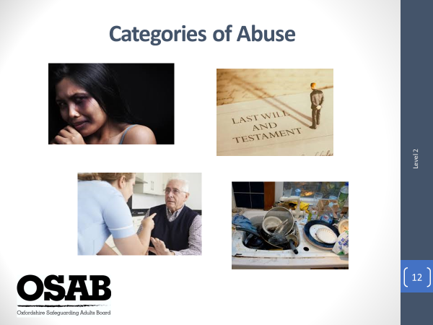

NOTE: Trainers to recap briefly on what has been covered so far; what safeguarding adults means, what is abuse, where it can take place, who can be an abuser, the legal framework, who adult safeguarding applies to and what support is available when a statutory safeguarding response is not appropriate.

Now the attendees are to take the time to consider different types of abuse. Trainers to inform that the Care Act 2014 statutory guidance sets out 10 distinct categories of abuse.

Ask people in small groups to consider what the 10 categories of abuse are, and what the indicators of these may be i.e. what might they see or hear that may give them cause for concern? Give 10 minutes for them to discuss.
If there is flipchart paper in the room it is useful for one of the Trainers to divide into two columns, the left for the category name, with the right showing the indicators. What should happen during this exercise is it becomes apparent that there are very similar indicators for different categories of abuse. It should also be noted that it is unusual for one category of abuse to be happening, without linking in with another.

In terms of the categories, it is important for Trainers to expand on any explanations given by groups by giving ‘real life’ examples.

Self-neglect - Lack of self-care to an extent that it threatens personal health and safety. Neglecting to care for one's personal hygiene, health or surroundings. Inability to avoid harm as a result of self-neglect.

Neglect & Acts of Omission - Neglect is defined as not providing reasonable, appropriate or agreed care or a failure to act in a way that any reasonable person would act.

Sexual - sexual activities which a person does not fully comprehend, to which they are unable to give consent, to which they object, or which may cause them harm.

Psychological – includes; threats to hurt or abandon, stopping someone from seeing people, humiliating, blaming, controlling, intimidating or harassing a person, verbal abuse, cyberbullying, isolation, and an unreasonable and unjustified withdrawal of services or support networks.

Physical – includes; assault, hitting, slapping, pushing, kicking, hair-pulling, biting; rough handling; scalding and burning; misuse of medication (e.g. over-sedation); inappropriate or unlawful restraint; making someone purposefully uncomfortable (e.g. opening a window and removing blankets), forcible feeding or withholding food.

Modern Slavery – includes; human trafficking, forced labour, domestic servitude, sexual exploitation, such as escort work, prostitution and pornography; debt bondage – being forced to work to pay off debts that realistically they never will be able to.

Financial or Material – includes; theft of money or possessions; fraud, scamming, rogue trading; preventing a person from accessing their own money, benefits or assets; undue pressure, duress, threat or undue influence put on the person in connection with loans, wills, property, inheritance or financial transactions; arranging less care than is needed to save money to maximise inheritance; misuse of personal allowance in a care home; misuse of benefits or direct payments in a family home; false representation, using another person's bank account, cards or documents
misuse of a Power of Attorney, Deputy, Appointeeship or other legal authority

Discriminatory – This includes some forms of harassment, slurs or unfair treatment relating to a person’s; race, gender and gender identity, age, disability, sexual orientation, religion.

Organisational – This includes neglect and poor care practice within an institution or specific care setting, i.e. hospital or care home, or in relation to care provided in one’s own home. This may range from one off incidents to on-going ill-treatment. It can be through neglect or poor professional practice as a result of the structure, policies, processes and practices within an organisation.

Domestic - ‘Incident or pattern of incidents of controlling, coercive or threatening behaviour, violence or abuse by someone who is or has been an intimate partner or family member regardless of gender or sexuality’ It can include; psychological, physical, sexual, financial, emotional abuse, so called ‘honour-based’ violence, female genital mutilation, forced marriage.

Other safeguarding issues; Mate crime, Cuckooing, Radicalisation (NB/ PREVENT). ALL ARE LOCAL AND NATIONAL ISSUES.

NOTE: hand out Threshold of Needs Matrix document once feedback received and inform how this should be used/referred to in delegates daily work.

It is important here to highlight the Consultation Line number and the use of it.

It is also important to highlight the need for workers to note in whatever records they have to use within their work that they have referred to the TofN Matrix and/or called the Consultation Line, and the outcome of such. This shows that they are adhering to the local policies around adult safeguarding.

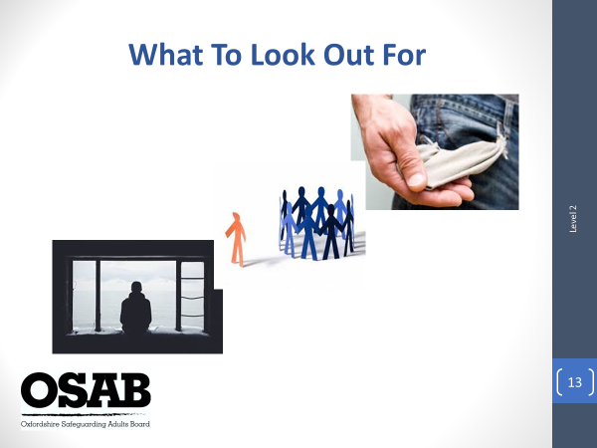

NOTE: This slide is designed to get attendees to not only consider what may make a person more vulnerable, but also, what may support them to be less vulnerable, along with cultural considerations and situations/signs that may alert attendees to concerns.

Trainer’s to ask the group to consider what they believe could lead a person to being more vulnerable to abuse and neglect and ask them to call out (separately!)

If there is flipchart paper available, one Trainer can write down answers. Trainers to confirm or challenge answers given.

Examples
Personal Characteristics:-
Not having mental capacity to make decisions about their own safety including fluctuating mental capacity associated with mental illness and other conditions
Communication difficulties
Physical dependency – being dependent on others for personal care and activities of daily life
Low self esteem
Experience of abuse
Childhood experience of abuse

Environmental Factors:-
Being cared for in a care setting, I.E. being dependent on others
Not getting the right amount or the right kind of care that they need
Isolation and social exclusion
Stigma and discrimination
Lack of access to information and support
Being the focus of anti-social behaviour
Financial challenges / cycle of deprivation
Coercive/controlling situations
Lack of autonomy

NOTE: Cultural differences should be discussed here too especially in terms of what may be acceptable in one culture, may not be in another. If something is a crime in the UK, culture does not constitute and excuse for abuse. If as a worker you do not understand or know something about a person’s culture, ask them.

Other issues may be i.e. an elderly person being averse to asking for support as it wasn’t something that was discussed or anything done about in their generation, for example, domestic abuse.

As in opposite-gendered couples, domestic abuse is underreported by people who identify as members of the LGBT+ community. There are many reasons why this may be the case, but one could be the person is afraid of revealing their sexual orientation or the nature of their relationship due to fear of discrimination.

Consider sex workers who are being exploited, are they likely to report to Police? Again, there may be many reasons why a person may not wish to, but one of those could be a fear of not being believed and/or prosecuted in terms of their work.

Honour-based abuse and forced marriage are still less visible and more covert crimes and incidents. All genders are perpetrators and abused.

Emotional resilience must be discussed here too. ER is the person’s own ability to look after their wellbeing which can help them deal with pressure, and reduce the impact that stress has on their lives. Resilience is not just about a person’s ability to bounce back, but also their capacity to adapt in the face of challenging circumstances, whilst maintaining a stable mental wellbeing. This can be achieved, for example by; making some lifestyle changes, looking after their physical health, giving themselves a break and building their own support network

Natural support – does the person have a supportive family, friends, do they attend community groups, faith meetings? Natural support can be another protective factor.

NOTE: There are many signs/situations that may alert you to a safeguarding concern. One of which is missed appointments. If someone does not attend, does it start to raise questions as to why, or is it just a case of two strikes and their case is then closed? The reasons could be many; for example, the way the appointment has been communicated, the person cannot afford to get to the appointment, the person is in a coercive and controlling situation where they are unable to attend.

Break of 5-10 minutes depending on how the session timings are going.

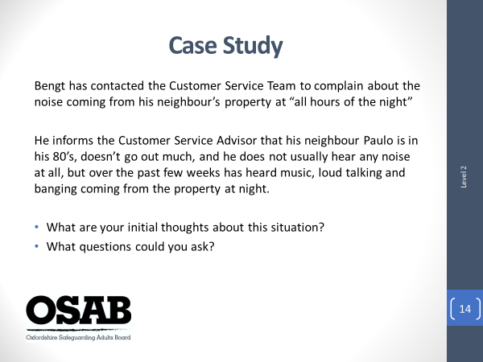

NOTE: Bengt is pronounced ‘Benkt’ – Paulo is pronounced ‘Pawlo’. This slide is designed to get delegates to reflect on everything discussed so far, but also to highlight potential subconscious and personal biases and/or organisational perspectives of potential safeguarding concerns.

(Trainers need to consider carefully how to approach this slide. The idea is to draw out that we can all have unconscious biases, how they can affect our thought processes and ways in which we approach a situation. It is also designed to draw out that depending on the organisation and type of work people carry out, responses to this situation may differ)

Trainer’s to ask attendees to read the slide and feedback straight away. Not to put too much thought into it. In this way, hopefully responses will be more spontaneous, rather than deeply considered.

How do our own beliefs, experience and attitudes influence our decision-making and potentially increase vulnerability? Did attendees feel more sympathetic and concerned about Paulo as he is in his 80’s? Did a ‘caring’ element come out in the delegates responses? Did they consider that Paulo may be a fit and healthy man in his 80’s, or did they think he’d be frail?

What if the case study had stated Paulo was in his 20’s and had substance misuse issues? What would the attendee’s thoughts have been then? Potentially drawing out a concern for an older man who could be being abused by others, as opposed to a younger man who may be the ‘problem’?

NOTE: The discussion this slide provokes can be challenging at times. Trainers are to ensure they approach it with confidence in the message that is being given, without being patronising or controversial in approach.

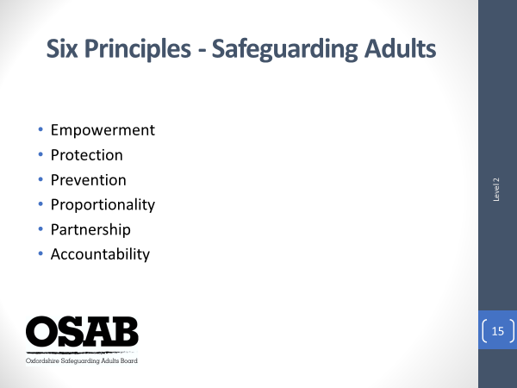

The principles are set out in the Care Act 2014 and statutory organisations have to follow them within their work with people, but they are a useful consideration for anyone working with people. And most people within their work will be working within these principles as they are really about best practice.

The main message is for workers to take a person-centred approach. When you work in this way you are placing the person’s wellbeing and needs at the forefront of everything you do.

What does each word actually mean?

Empowerment – people being supported and encouraged to make their own decisions and give informed consent. Talk to the individual. What do they want? What are their thoughts about the situation?

Protection – staff must ensure that they know what to do when abuse has happened. Is there anything that can be done (with the person’s consent) to immediately reduce the risks faced? Who do you need to inform in your organisation?

Prevention – the fact that you are on this training helps with prevention, as you should be able to spot the signs of abuse and have the confidence to report suspected abuse without putting the person at further risk.

Proportionality – the least intrusive response appropriate to the risk presented. Don’t be ‘risk averse’ and make something appear worse than it is, and don’t ignore risks/situations either. Respect the person, think about what is best for them and only get involved as much as needed. Don’t apply a “one size fits all” response.

Partnership – You should work in partnership with each other and local communities. Local people, family members, visiting professionals also have a part to play in preventing, detecting and reporting abuse. Sharing information is an important aspect of partnership.

Accountability – Safeguarding is everybody’s business. Everyone must accept that we are all accountable as individuals, services and as organisations.

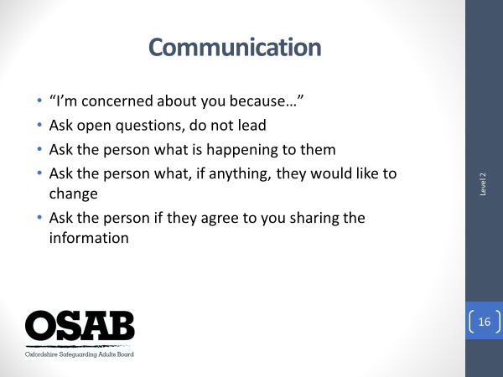

NOTE: Acknowledge that attendees on this course are unlikely to build long term working relationships with people they may have concerns about, but the communication they have (even if during one telephone call) is really important as it may be the one and only time the situation has been acknowledged and the person has been asked about it.

Effective communication with people is useful in order to gain relevant information.

If someone makes a disclosure to you, you have witnessed an incident, or you have picked up on signs that may point to abuse occurring, you must speak with the individual (although acknowledgement should be given to the fact this is not always possible, depending upon circumstances) Trainers to give examples of where it may not be possible i.e. the perpetrator may be listening in to the phone call, or is there with the person etc.

Further considerations around communication:-

People with sensory impairments i.e. sight loss, hearing loss?
A person who does not speak a language that you speak?

Do you utilise a family member or friend to assist the person? NB/ Sometimes ‘friends’ or ‘family’ can be the people who are abusing the person. If in any doubt, request an independent BSL interpreter/language interpreter to assist with communication.

It is always useful to check out your understanding of the situation/disclosure with the person. Repeat back what they have said. This can help to reduce the likelihood of misunderstandings.

NOTE: Trainer’s to emphasise that it is very important that any attempts at communication do not put the person at greater risk of harm.

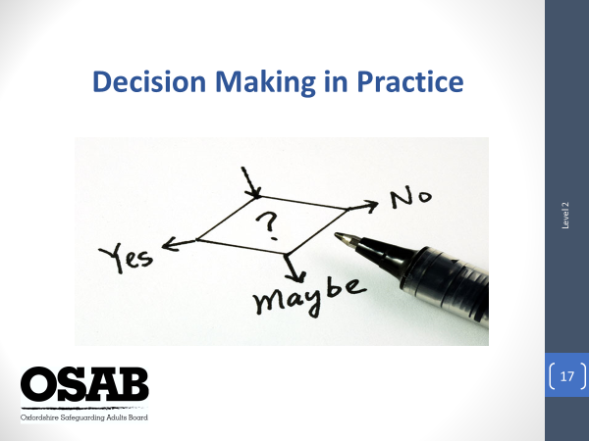

NOTE: The Mental Capacity Act 2005 is a key piece of legislation that should be used by anyone who is involved in the care, support and/or treatment of a person over 16 years of age.

Brief exercise: with the person next to you, please have a quick discussion about what you had for breakfast this morning (if you did). Consider how you reached your decision? What did you need to take into account to make the decision? Did you feel able to make the decision without support from others?

Then talk about a person having capacity only if they can carry out all four of the steps:-

Understand appropriately-presented information about that decision;
Retain the information for long enough to;
Use and weigh it to make a decision, and;
Communicate the decision by any recognisable means.

Talk about how people may be able to make some decisions, but not others. Talk about fluctuating capacity and why. DECISION and TIME SPECIFIC.

This does not need to be discussed in great depth due to the remit of the role of attendees likely to attend this training.

The main message is, do not make assumptions about a person’s ability to make a specific decision (i.e. if they have a substance addiction). If they are unable to make a decision there and then, can it wait?

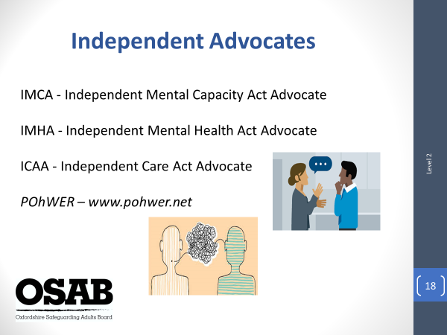

It may be within your work it comes to light a person has an Independent Advocate working with them. It is therefore essential that the Independent Advocate is part of any discussions with/about the person.

When does a person need an Advocate?

As a requirement of The Care Act 2014, if it appears to the authority that a person has care and support needs, then a judgement must be made as to whether that person has substantial difficulty in being involved and if there is an appropriate individual to support them. An Independent Advocate must be appointed to support and represent the person to assist their involvement, if the two conditions are met and if the individuals are to take part in safeguarding enquiries. There are also other instances such as assessments of need and reviews, but here we are focusing on an individual participating in a safeguarding enquiry.

What are the different Advocates?

IMCA – is an advocate who has been specially trained to support people who are not able to make certain decisions for themselves and do not have family or friends who are able to speak for them. IMCAs do not make decisions and they are independent of the people who do make the decisions.

IMHA – is an independent advocate who is trained to work within the framework of the Mental Health Act 1983 to support people to understand their rights under the Act and participate in decisions about their care and treatment. Advocates are not employed by the NHS or any private healthcare provider.

ICAA – is an advocate who understands the care and support process. They will be actively involved in discussions about a person’s care and support needs, will challenge plans made if they do not take account the person's wishes or feelings.

Other forms of advocacy include; Independent NHS Complaints Advocacy, help people to use the NHS complaints process which covers all NHS funded treatment; Community Advocacy, A community advocate is someone who offers advocacy that is not based on a legal right. In other words, it is not offered to you because the law says you have to be offered it. It is for people who have an issue they are struggling with and feel they would like some help to deal with it.

Who runs the Advocacy service in Oxfordshire?

An organisation called PohWER are running the advocacy service.
Website details on the screen.
POhWER - 0300 200 0082 or email oxfordshireadvocacyhub@pohwer.net

If a person says they are a person’s Advocate, check out who they are, who they work for before discussing anything with them. If they are legitimate, they should understand why you are checking this out.

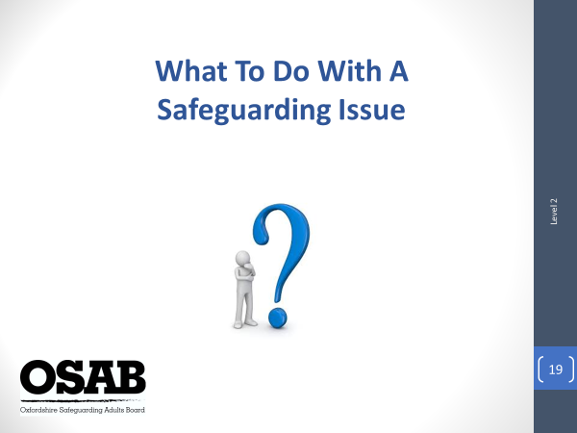

First and foremost, keep the person safe (if safe and appropriate to do so). If a person is at immediate and significant risk of harm, or it has occurred, please take appropriate steps, i.e. call Police, Fire or Ambulance services. Safeguarding is not a substitute for the emergency services!

Gain consent if able to – consent is not essential when deciding whether concerns should be raised. However, wherever possible you should discuss your concerns with the person and/or their representative and seek their consent. Are there any children and/or other adults with care and support needs involved, or is there a potential risk to others? If this is the case, consent can be overridden in the interests of protecting others.

Gain the views and wishes of the person concerned where you are able to.

Refer to the Threshold of Needs Matrix to consider whether the matter needs to be raised as a safeguarding concern, or whether a consultation call is required.

Always record what you have witnessed, hear or been told. It may seem relatively innocuous, but it may be that over time, more information is added that build a picture of the harm that may have, or is occurring.

Seek advice and support from a senior member of your team as to the next steps you, or they, need to take.

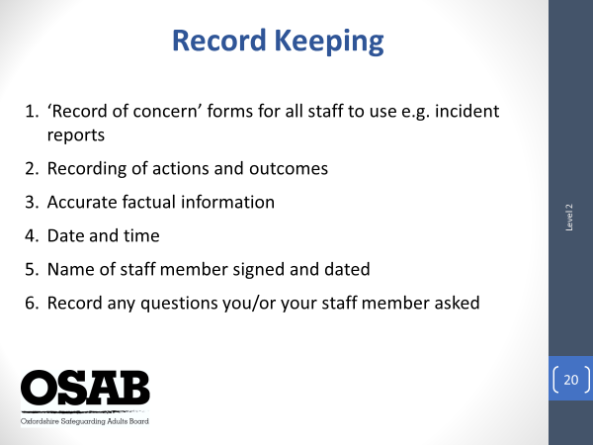

NOTE: Acknowledge that different organisations will have different recording systems, but the main points on the slide are relevant in any place of work.

Record keeping is important in all aspects of our work with people.

As a basic format, it is useful to record any incidents, or general concerns you have about a person within your organisation. This can help to build a picture of issues/situations that are occurring for that person, or even to show that support has been offered, but the person declined.

We are all very busy, but it is best practice to follow up to ensure matters have been considered and signposted or moved on to appropriate agencies.

If it’s not recorded, it didn’t happen!

Always record when you have considered the Threshold of Matrix against the concern you have, and the outcome i.e. no need to raise a formal safeguarding concern, call made to consultation line, formal safeguarding concern raised.

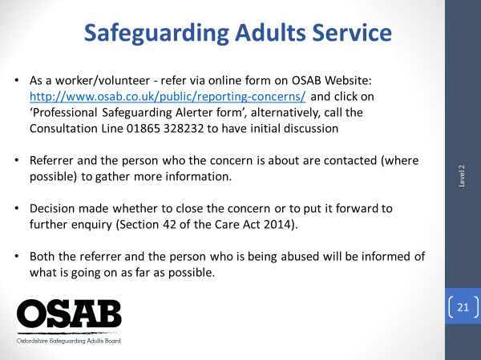

NOTE: This slide is to go through the process of how to formally report a concern to the Safeguarding Adults Service. Acknowledge that this is a basic outline of the initial process that is followed.

The slide should be self-explanatory.
If a member of the public wishes to raise a concern, they should be asked to contact the Social & Healthcare Team, Oxfordshire County Council on 0345 050 76 66 to report their concerns. The information collected will be considered and either passed to the Safeguarding Adults Service, or to another team within Adult Social Care if more appropriate. A further option is for them to complete an online form following the link on the screen but need to click on ‘General Public Alerter form’.

If a referrer disagrees with any decisions reached by the Safeguarding Adults Service, this should initially be discussed with the person who made the decision. If this does not resolve the matter, ask to speak with a Practice Supervisor. If this does not resolve the matter, escalate to the Team Manager, Fay Brown. Safeguarding Adults Service telephone number is 01865 328232.

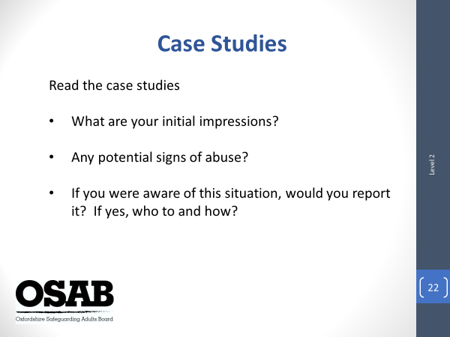

NOTE: You should have reached this slide by 11.15am at the latest. There are six case studies in total. Please ask attendees to work in their groups. Give up to 20 minutes for them to consider the content. This then leaves a further 20 minutes for feedback on the case studies (if there isn’t time to feedback on all 6, cover as many as possible).

Trainer’s to inform attendees that this is their opportunity to consolidate all the learning from the session. Ask them to refer to the Threshold of Needs Matrix when considering each case study as this will get them to start to understand how it can assist them and their colleagues when a concern arises.

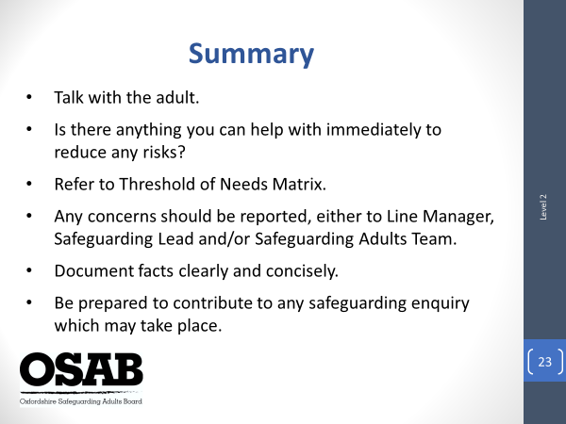

Trainers to recap that the session has been about raising awareness of adult safeguarding and ‘everybody’s responsibility’ around it. Read out the points on screen.

If anyone wishes to undertake further training around safeguarding issues, they should go to the Training section of the OSAB website where they will find details of other training available.

Please check that everyone has signed the register. Inform attendees that they need to log into their OSAB account to complete an evaluation form. Once completed, they will have the opportunity to download their Certificate of Attendance.

Please remind attendees that evaluation forms are read, and comments are considered in terms of any changes to the training that may be required and affords feedback for Trainers on their delivery of the training.

Any further questions?

END OF SESSION

And finally…

THANK YOU for being a Trainer for Oxfordshire Safeguarding Adults Board. I hope the delivery of sessions go well and they are enjoyable experiences for you.

Regards,

Helen Kershaw,
Learning & Engagement Officer,
Oxfordshire Safeguarding Adults Board

