Level 3 Caseworker Course
Trainer Handbook

Duration: 3.5 hours – 09:30 to 13:00 hours

This training has been designed to assist frontline workers who are working with adults and carers, who could potentially contribute to assessing, planning, intervening and evaluating the needs of an adult where there are safeguarding concerns.

The training is offered via OSAB as multi-agency training and is delivered via our pool of trainers from agencies who work in the field of adult safeguarding.

Level 3 Caseworker training is valid for up to 3 years.

Target audience:

All who work with and have frequent contact with adults and/or carers as part of their work, paid or voluntary, for example; Support workers, Housing Officers, Social Workers, Occupational Therapists, Care workers, Dementia Advisors, Further Education staff, Healthcare assistants etc.

OSAB Contact:
Helen Kershaw, Learning & Engagement Officer
07747 008 359
Helen.kershaw@oxfordshire.gov.uk please also cc to osab@oxfordshire.gov.uk

Contents Page

Slide Title | Page Number | Time/Minutes
Title Page | 3
Aims & Objectives | 3
Welcome, housekeeping and introductions | 4 | 15 mins / 9.30 – 9.45
Training Agreement (Ground rules) | 5
Vulnerabilities & strengths | 6/7 | 30 mins / 9.45 – 10.15
Local and National Issues | 8 | 15 mins / 10.15 – 10.30
Legal Framework | 9/10/11
Confidentiality, information sharing & consent | 11/12 | 15 mins / 10.30 – 10.45
Decision making in practice: scenario | 13 | 20 mins / 10.45 – 11.05
Independent Advocates | 14 | 5 mins / 11.05 – 11.10
BREAK | 14 | 10-15 mins / taken at 11.10am
Assessing risk & protection planning (header page) | 15 | 15 mins / 11.25 – 11.40
Assessing risk & protection planning | 16
Jigsaw Puzzle | 17 | 30 mins / 11.40 – 12.10
How to refer a concern | 18
Adult safeguarding process | 19/20 | 10 mins / 12.10 – 12.25
Section 42 enquiries | 20/21
A response that surprised you | 21/22 | 5 mins / 12.25 – 12.30
Learning from reviews | 23/24/25 | 10 mins / 12.30 – 12.40
Looking after yourself in safeguarding | 25 | 5 mins / 12.40 – 12.45
Summary & Questions | 26 | 10 mins / 12.45 – 12.55

Trainer’s notes:

For every session you deliver, please arrive in plenty of time to set up laptops, screens etc., and to ensure that everything is working before the session starts.

Not every venue sets out tables as we ask. It will be you and your co-Trainer’s decision as to whether you wish to move tables and chairs into a different arrangement than you found it. There is no expectation from OSAB that you will do this.

Not every venue has refreshment facilities. This has been explained in the confirmation email that goes out to people who register for training, with a request that they bring their own refreshments if they require them.

The timings are a guide as to which slide we would hope you are on at a certain time within the training. Obviously, this will partly be dependent upon the conversations that have taken place and questions that have arisen.

It is for Trainers to decide when a point has been discussed enough, and to respectfully move things along, or when to expand on points raised.

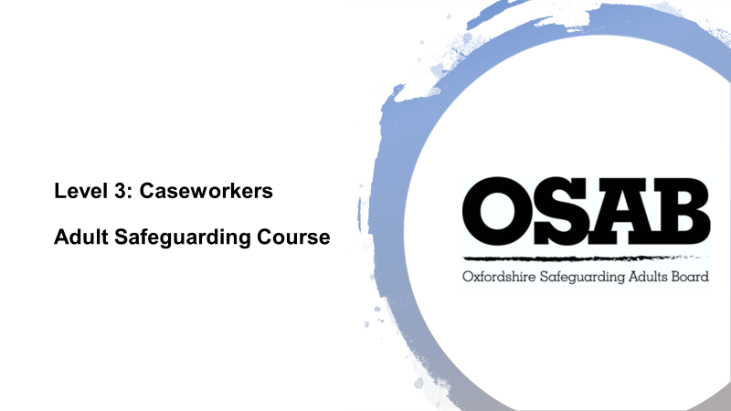

This slide is to be on the screen as delegates are entering the room, before you start to deliver. It is always worth checking that everyone is expecting to be on this course, and not another. OSAB sometimes deliver training in venues at the same time as Oxfordshire Safeguarding Children Board, and people have been known to be in the wrong training session!

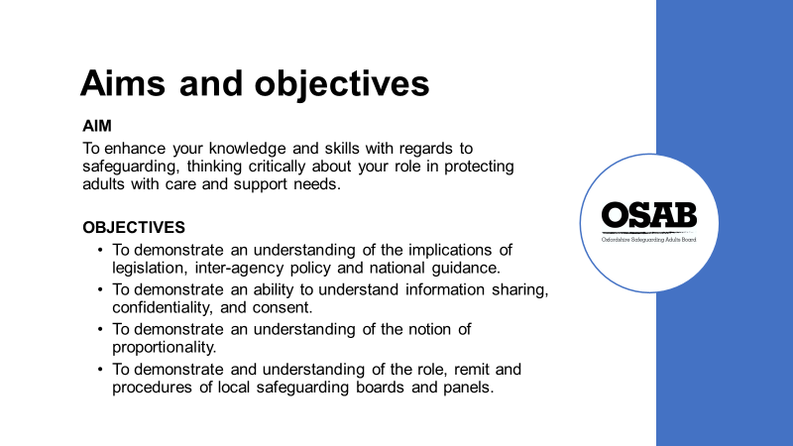

Ask delegates to view the aim and objectives of the training and check that people are happy with the course overview.

Trainers: It is worth acknowledging here that for some people in the room, this training may act as refresher, and for others it may be their first time of working directly with people and therefore require an understanding of adult safeguarding. Request attendees respectfully acknowledge they may have different amounts of experience.

The training is designed to provide the opportunity for people to learn and work together, exploring professional dilemmas in a multi-agency context. Acknowledge the experience of the people in the room and ask people to participate and share experiences as it helps everyone’s learning.
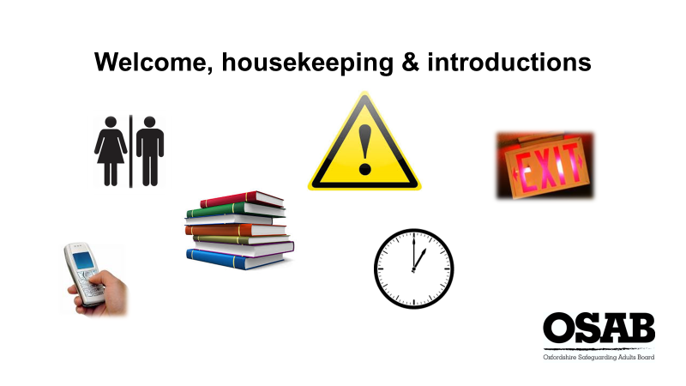

Please ensure you know where toilets and fire exits are located, whether any ‘tests’ are due in terms of fire drills etc., and where you would need to congregate if an alarm goes off.

Course timings – 3.5 hours in length, a break of 10 minutes. Please inform attendees that if anyone needs a comfort break of any kind outside of the formal break, they are free to do so and do not have to ask.

Course materials – the joining email will have stated copies of slides and further information will be sent after the course today, but please remind people of that.

NOTE: Please remind everyone to sign the register as they will be marked as not attending if they do not.

Mobile phones: Switched to vibrate or silent. If anyone needs to take a call, please leave the training room to do so and return to the session if they can. Please ask people not to sit checking their social media accounts. They will be called out if they do!

‘Health’ warning: the training covers some emotive areas. Please remind attendees that if they’re struggling with any issues the course raises, they can take time out or speak to the Trainer during a break/at the end of the course.

Introductions: Trainers should describe their own role and the organisations they work for. This helps to establish their credibility as someone to present on safeguarding (don’t forget add-ons to your role such as being a Best Interest Assessor, AMHP etc.)

Next ask the attendees to introduce themselves to the whole group. It would be good to hear their name (first name will suffice), what their job role is and which organisation they work for (no acronyms please) and the people their organisation support/type of work.

It is here that it is useful highlight how networking with each other helps us to gain an understanding what support is available for people.

This is also a useful exercise for you as Trainers as it gives you the opportunity to gain an understanding of who is in the room and how to direct the content at certain points, i.e. some more explanation may be required, or an acknowledgement that certain professions may already have a good understanding of certain aspects, but it may be a relatively new concept to others etc.

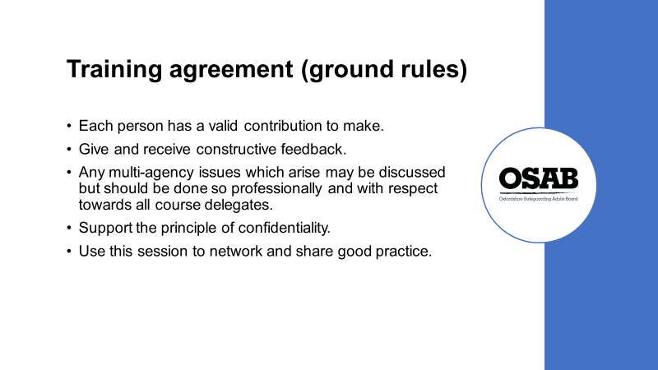

Safeguarding adults work is about sharing information and working together, i.e. some workers will be involved with an adult only at the point of crisis, others may have long standing working relationship before safeguarding issues are raised. All workers and individuals are important, and by working together we see good practice and better outcomes for adults. Sensitivity and support for each other is important both in group training and at work.

Personal backgrounds and experiences will vary, all have different, valuable perspectives to draw upon. Any agency barriers that arise will be addressed; however, all attendees must be made to feel welcome and at no stage should be a ‘target’ for any agency barriers. Attendees should also be asked to be sensitive in how points are made when discussing other agencies.

Discussion within the group is confidential unless the Trainer deems there has been a disclosure that puts an adult(s), child(ren), the attendee or the Trainer at risk. In this case, the Trainer has an obligation to report it.

Identify that real people’s situations may be used, but confidentiality should be maintained; therefore, no names, addresses of individuals or colleagues should be mentioned. Real situations are used to help make training more realistic and to help focus on certain elements. Attendees may recognise some of the information used and should they at any stage feel aspects are not being correctly represented, they should speak to the Trainers.

As safeguarding is everyone’s responsibility, it is useful to mention that the training is about worker’s feeling confident about adult safeguarding. The training aims to ensure a difficult subject is considered with sensitivity and positivity.

Encourage people to ask for clarifications and question when they don’t understand, or don’t agree. Remind people that participants will have a varying degree of experience in safeguarding and any challenge should be respectful.

Trainers should ask delegates to be mindful of jargon and to explain any abbreviations. Learning is about participation and positivity

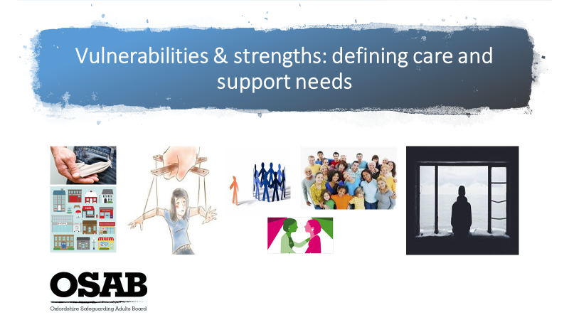

This slide is designed to get attendees to consider who may require support from a safeguarding point of view, because not every adult does.

This exercise is ultimately designed to highlight who may require support around safeguarding concerns, and who may not. It is important that assumptions are not made based upon a person’s diagnosis and/or presentation. A person should always be asked their thoughts, views and wishes about any concern’s workers may have.

EXERCISE: Ask attendees to form small groups to discuss a) what types of abuse are there? b) what may make a person more vulnerable to abuse i.e. personal and environmental issues?, c) what indicators may be present that could indicate possible abuse?, and d) what strengths a person may have that may mean they can protect themselves from abuse? Give the groups 10 minutes to discuss, then ask for feedback.

Types of abuse
Trainers : Threshold of Needs Matrix highlights the 10 categories as defined in the Care Act 2014 guidance. It also highlights some others that are prevalent issues in Oxfordshire.

Examples of vulnerabilities:-
Not having mental capacity to make decisions about their own safety, including fluctuating mental capacity associated with mental illness and other conditions.
Disabilities – physical and/or learning.
Communication difficulties.
Being homeless.
Substance use issues.
Being dependent on others for personal care and activities of daily life.
Low self-esteem.
Experience of abuse.
Childhood experience of abuse.
Being cared for in a care setting, i.e. Care/Nursing Home, supported living.
Not getting the right amount or the right kind of care that they need.
Isolation and social exclusion.
Stigma and discrimination.
Lack of access to information and support.
Being the focus of anti-social behaviour.
Financial challenges.
Coercive/controlling situations. Lack of autonomy.
Local authority duties for safeguarding enquiries (Section 42) and safeguarding adults reviews (Section 44) do not apply to adults living in prisons or approved premises (i.e. bail hostels), inmates of which are the responsibility of that specific institution. Adult safeguarding in prisons means keeping prisoners safe and protecting them from abuse and neglect. Prison staff have a common law duty of care to prisoners that includes taking appropriate action to protect them.
Further reading https://www.justice.gov.uk/downloads/offenders/psipso/psi-2015/psi-16-2015-adult-safeguarding-in-prisons.pdf

Examples of possible indicators:-

Not attending appointments, i.e. could be due to memory loss, busy life/forgot, neglect by an informal carer, informal carer stress?
Always attending appointments with someone else and referring to that person. Not answering questions themselves, i.e. they are struggling to understand, memory issues (either temporary or permanent), the person is controlling them.
Changes in the person’s circumstances i.e. could be good (more money), could have a new group of friends (could be positive, may not be)
Unexpected or unexplained changes in behaviour i.e. person could become angry or alternatively, withdrawn.
Unexplained or account given does not correlate to injuries observed.
Unpaid bills. Sexually transmitted diseases. Untreated medical issues.
Unwanted pregnancy. Decline in personal appearance.

Examples of strengths:-

Stress and resilience should be considered when discussing all these factors as they will heavily influence the impact on the person.

What ‘natural support’ does a person have and how much can they be relied upon by the person i.e, family, friends, community and/or faith groups? Who, or what does the person connect with in their local community on a daily/regular basis?

What services/organisations does the person engage in? Do they attend regularly? Is there a worker(s) that they trust and can talk to?

Resilience. Can the person recover quickly from unfortunately circumstances or illness?
Does the person have experience and knowledge necessary to deal with the potential difficulties or dangers of life?

If a person has layers of vulnerabilities i.e. personal and environmental and very little ‘protective factors’, they may be more vulnerable to being abused.

Vulnerabilities + indicators + no strengths = more vulnerable?
Vulnerabilities + indicators + strengths = less vulnerable?

When working with people it is useful to have an approach of vigilance. Indicators of potential abuse are important and should not be ignored.

Trainers to hand out Threshold of Needs Matrix at the end of the activity and discussions. Explain how it should be used within attendees daily work to assist in their decision whether a concern should be formally raised as a safeguarding concern. Explanation to be given about how to use the document. The Consultation Line number is to be highlighted specifically. It is useful for anyone in doubt about whether to refer a safeguarding concern, or potentially just needing to talk through a concern to gain a professional opinion.

EXERCISE (Allow 10-15 minutes for discussion, feedback and comparisons to local and national figures

Ask the attendees to discuss in their groups, the following questions:-

- In your experience within your work, what would you say is the most prevalent type of abuse that you come across?
- Who would you say are the most likely group of people to be abused?
- Where do you believe most abuse is likely to take place?

This offers attendees the chance to share more of their experience with each other. Trainers to ask for feedback from each group.

You can then link in the local and national figures below which may correspond with what attendees have highlighted.

Local (Oxfordshire) figures:-
From 2018/19 data, the primary support reason that accounted for half of the formal safeguarding concerns raised was ‘Physical/Personal care support’ (49.66%), Learning Disability support (12.14%) and Mental Health support (7.6%)
Data within Oxfordshire does not account for age ranges.
The most common type of risk in Section 42 enquiries that concluded in the year (2017/18) was Neglect and Acts of Omission (643), with Psychological (379) and Financial & Material (344) abuse categories being the next most prevalent categories.

National figures:-
Older people are more likely to be the subject of a S42 enquiry with 1 in every 43 people aged 85+, compared to 1 in every 862 people aged 18 to 64.
The most common type of risk in Section 42 enquiries that concluded in the year (2017/18) was Neglect and Acts of Omission, which accounted for 32.1% of risks, and the most common location of the risk was the person’s own home at 43.5%.
(taken from Safeguarding Adults England, 2017-18, Experimental Statistics by NHS Digital)

Further reading recommendation:-
Article by Action on Elder Abuse published on 17th July 2019 https://www.elderabuse.org.uk/breaking-news states “A new joint report by HM Inspectorate of Constabulary and Fire & Rescue Services (HMICFRS) and HM Crown Prosecution Service Inspectorate (HMCPSI) entitled ‘The poor relation. The police and CPS response to crimes against older people’, makes a series of recommendations. The damning report states that older people are “often let down by the police and wider criminal justice system which does not always understand their needs and experiences”.

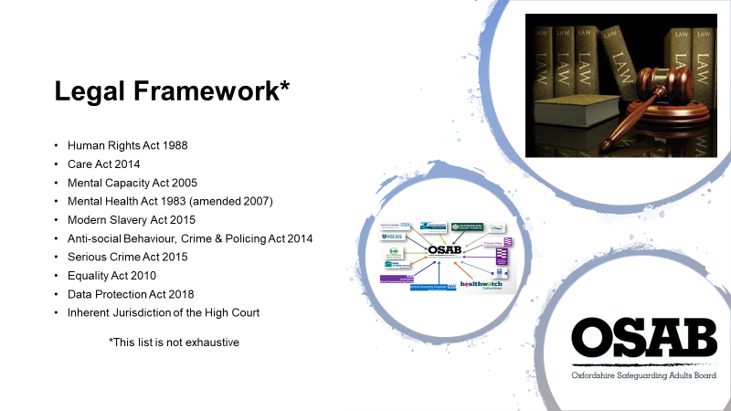

Depending upon people’s role within their organisations, they may not necessarily realise that certain pieces of legislation will be relevant to the work they carry out with people. ‘Legal literacy’ is something everyone should use within their work.

Legal literacy = integrating law (doing things right), ethics (doing right things), and rights (rights-based thinking)

Legal rules and an ethical duty of care should be at the centre of our work. Both must influence our decision-making, which must be embedded in a recognition of a person’s human rights.

Legislation makes clear that adult safeguarding responses should be guided by the adult themselves, to achieve the outcomes that they want to achieve.

Trainers to refer to the slide and emphasise ‘*This list is not exhaustive’ as it would be near impossible to highlight all relevant Acts!

Trainers: If you wish to, you can inform people of the focus of each Act on the slide, but you may lose the interest of some attendees if you do this. It is worth highlighting though; Care Act 2014, Mental Capacity Act 2005, and Inherent Jurisdiction of the High Court.

Human Rights Act – Sets out the fundamental rights and freedoms that everyone in the UK is entitled to, set out in a series of ‘Articles’ – Article 4: freedom from slavery and forced labour, Article 8: respect for your private and family life, home and correspondence.

Care Act – consolidated many different laws around Adult Social Care. It sets out the Local Authority’s duties around assessment and eligibility - Section 1 duty to promote wellbeing.
It put safeguarding on a statutory footing as it was previously covered in guidance as opposed to set in Law.

Adult safeguarding was previously a non-statutory policy directive, set out in the ‘No Secrets’ document. The Care Act brought adult safeguarding onto a statutory footing.

Section 42 sets out the local authority’s duty to make safeguarding enquiries. Section 43 requires every Local Authority to establish a Safeguarding Adults Board (SAB) for its area. The SAB operates at a strategic level, helping and protecting adults in its area from abuse and neglect through co-ordinating and reviewing a multi-agency approach across all member organisations.

Mental Capacity Act – In its basic form, the MCA is about whether people are able to make specific decisions for themselves, and if they are not, how and when decisions can/should be made in their ‘Best Interests’.
Liberty Protection Safeguards are currently being considered to replace Deprivation of Liberty Safeguards. Likely to come info force around October 2020.
Section 44 of the MCA prioritises people’s safety by making wilful neglect or mistreatment of an adult who lacks capacity to make decisions a criminal offence.

Mental Health Act – Sets out when a person can be admitted, detained and treated in hospital against their wishes due to a ‘mental disorder’ (specific term used in the MHA) . They have rights to appeal and gain support from an Advocate too.

Modern Slavery Act – Another law that consolidated previous legislation. It’s designed to tackle slavery and trafficking in the UK.

Anti-Social Behaviour, Crime & Policing Act – Designed to target crime and anti-social behaviour. 1998 Crime & Disorder Act created the ASBO. Forced marriage offences are covered under Section 121 of the Anti-Social Behaviour, Crime and Policing Act 2014

Serious Crime Act – Section 76 created an offence of controlling or coercive behaviour in an intimate or family relationship.

Equality Act – puts a responsibility on public authorities to have due regards to the need to eliminate discrimination and promote equality of opportunity. What behaviour counts as unlawful discrimination, and who has a right to challenge discrimination.

Data Protection Act – (will be covered in the following slide)

Inherent Jurisdiction of the High Court – In extreme cases where there is a serious risk to life, and where all other legal and support avenues have been exhausted, an application can be made to invoke the inherent jurisdiction of the High Court. However, the courts will always strive not to undermine the principles in Section 1 of the Mental Capacity Act (Wellbeing), especially in relation to unwise decisions. The purpose of the inherent jurisdiction is not to overrule the wishes of an adult with capacity, but to ensure that decisions are being made freely.

It is important to be aware that there will be some safeguarding situations where the person may appear to be mentally capacitated but is in fact subject to duress or coercion by another person. If this is the case, Mental Capacity Act procedures may not cover the particular situation.

Professionals from a range of disciplines will need to work with the person, to explore options that may be available to keep them safe. Supporting people who are subject to coercion is often complex and challenging work. If the situation cannot be resolved in other ways, an application to the Inherent Jurisdiction of the High Court may need to made.

Your Legal Department should always be contacted if this course of action is being considered.

Case law is also worth having knowledge of (depending on the remit of your role, and/or professional interest). Case law is the set of rulings from court judgements that set precedents for how the law has been interpreted and applied in certain cases.

Where to find case law? – Research in Practice for Adults (RiPfA) organisations must sign up to be members of RiPfA. Local Government Ombudsman. 39 Essex Chambers.

To recap: Legal literacy is needed when working with people in a safeguarding context. If unsure of what Acts apply to certain situations, seek advice from senior staff within your organisation.

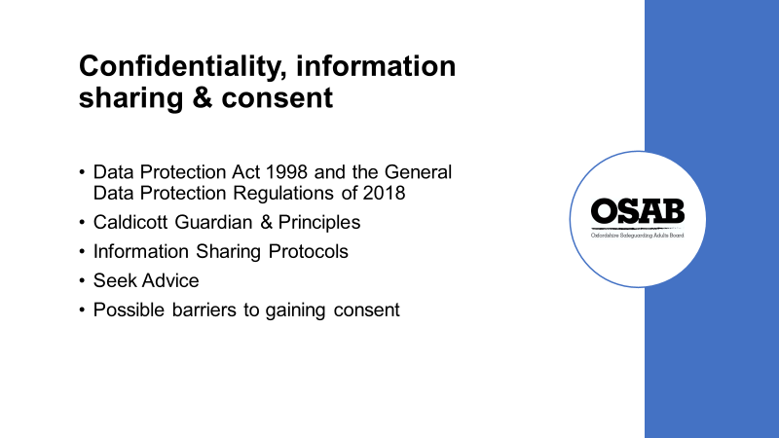

This slide is designed to acknowledge that workers can be unsure whether to and what information to share in safeguarding situations. The points on the slide are to help offer guidance in such situations.

The Data Protection Act 2018 (DPA) controls how a person’s personal information is used by organisations, businesses or the government.

The DPA is the UK's implementation of the General Data Protection Regulation (GDPR). Everyone responsible for using personal data must follow strict rules called 'data protection principles'. They must make sure any information is; used fairly, lawfully and transparently, used for specified, explicit purposes, used in a way that is adequate, relevant and limited to only what is necessary, accurate and, where necessary, kept up to date, kept for no longer than is necessary, handled in a way that ensures appropriate security, including protection against unlawful or unauthorised processing, access, loss, destruction or damage.

Caldicott Guardian & Principles. A Caldicott Guardian is a senior person responsible for protecting the confidentiality of people's health and care information and making sure it is used properly. Caldicott Principle’s set out six Principles that organisations should follow to ensure that information that can identify a patient is protected and only used when it is appropriate to do so. All NHS organisations and local authorities which provide social services must have a Caldicott Guardian and follow the 6 principles.

Information Sharing Protocols. All organisations should have (and workers should be familiar with) information sharing protocols. If in doubt about sharing information, seek advice, from senior staff within your organisation and/or your organisation’s written policies.

The risk of sharing information is often perceived as higher than it actually is. It is important that staff consider the risks of not sharing safeguarding information when making decisions.

Consent

If a person refuses intervention to support them with a safeguarding concern, or requests that information about them is not shared with other safeguarding partners, their wishes should be respected.

However, there are a number of circumstances where the practitioner can reasonably override such a decision, including:

- lack of mental capacity to make that decision (this must be properly explored and recorded in line with the Mental Capacity Act),
- other people are, or may be, at risk, including children,
- sharing the information could prevent a crime,
- the alleged abuser has care and support needs and may also be at risk,
- a serious crime has been committed, staff are implicated, the person has the mental capacity to make that decision, but they may be under duress or being coerced,
- the risk is unreasonably high and meets the criteria for a multi-agency risk assessment conference referral,
- a court order or other legal authority has requested the information.

Why might a person not want their information shared?

There can also be Issues around people seeking or accessing help, for example:

- for some communities. issues are expected to be dealt with internally without outside help and there have been examples where families have failed to seek appropriate support for disabled relatives as their religious leaders have deemed it a test of their faith or a punishment for a sin.

- a person with previous experience of professionals, i.e. as a child, they may not trust social services or other partners, or a person who has been sexually exploited may be viewed as a sex worker who has made a conscious decision to ‘work’ in that field. They may therefore be unwilling to inform the Police or other workers deemed to be in a position of authority about their situation in case they aren’t believed, or even possibly arrested.

- a person may be frightened of reprisals, may fear losing control, or may fear that their relationship with the abuser will be damaged, i.e. a person living in a Domestic Abuse situation may not wish to say anything if their abuser is their informal carer. Not only could they risk the situation getting worse if they tell someone and the abuser finds out, but they could risk having no-one to help meet their care needs.

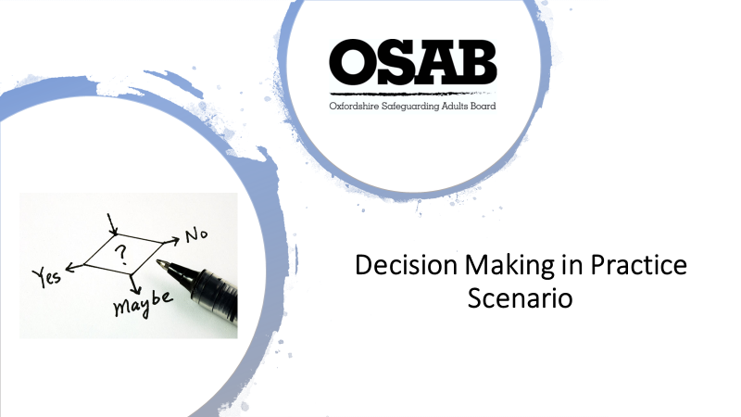

The Mental Capacity Act (MCA) 2005 applies to everyone involved in the care, treatment and support of people aged 16 and over living in England and Wales who are unable to make all or some decisions for themselves.

The MCA is designed to protect and restore power to those people with vulnerabilities who lack capacity.

EXERCISE:

The scenario is designed to put into practice the caseworker’s knowledge of decision making in practice in a safeguarding context. They do not have to be a Social Worker or have in depth knowledge of the Mental Capacity Act to work through the scenario. They need to consider how people usually make decisions and that the person should be central to any decision(s) taken.

The Mental Capacity Act 2005 cards are to be handed out at this stage to assist attendees.

Trainers to go around the groups to see whether anyone needs help and ensure discussions are relevant.

Hand out Part 1 initially, ask the groups to discuss and consider the questions posed. Give them 5 minutes to discuss, then seek feedback for the whole group to hear.

Then hand out Part 2, again, ask the groups to discuss and consider the questions posed. Give them 5 minutes to discuss, then seek feedback for the whole group to hear.

Please give 20 minutes to complete this exercise.

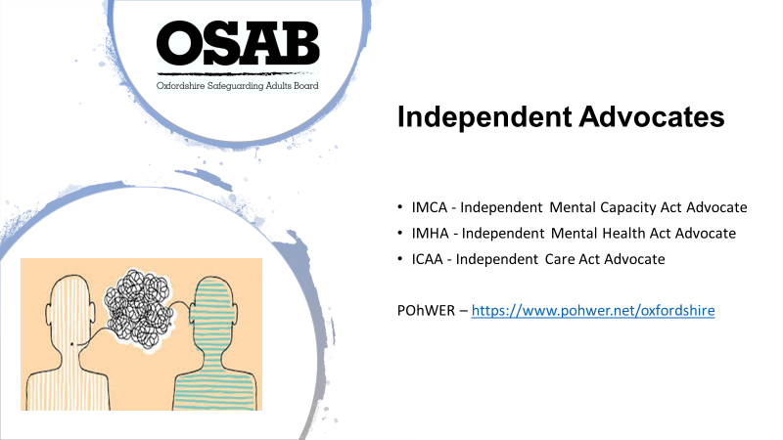

Section 67 of the Care Act 2014 imposes a duty on Local Authorities to arrange for an Independent Advocate if it appears a person has care and support needs, has substantial difficulty in being involved in decision making, participating in assessments and reviews, and whether there is an appropriate individual to support them.

An Independent Advocate must be appointed to support and represent the person to assist their involvement, if the two conditions are met (care and support needs, and substantial difficulty) when an individual is to take part in safeguarding enquiries.

POhWER are providing Advocacy Services in Oxfordshire. More information can be gained from their website (noted on slide).

POhWER also offer:-
•NHS Complaints Advocacy
•Community Advocacy

Thorough record keeping is VITAL (use of advocates, Mental Capacity Assessments, etc), it needs more than just a yes or no, i.e. “this person lacks capacity” is not valid!

Talk about the need to note when an Advocate has been requested and link to the relevant Mental Capacity Assessment (decision and time specific)

If the only ‘appropriate person’ is the potential perpetrator of the abuse, then are they ‘appropriate’?

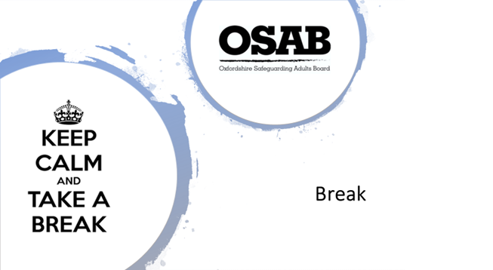

10 – 15 minutes depending on how time is going. If running a little late, make it 10 minutes.

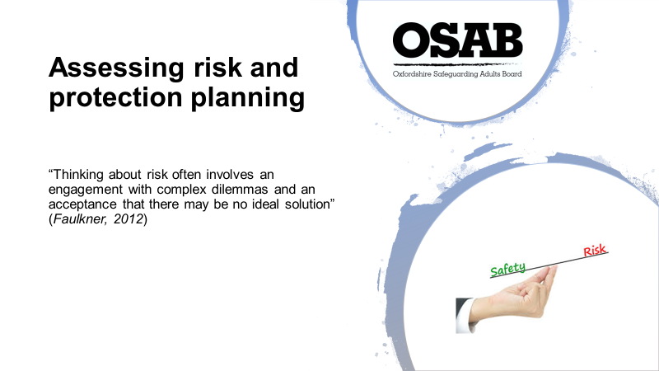

This slide is an introductory slide. The quote is designed to remind attendees that supporting adults can be complex at times.

Where a person’s role includes conducting detailed assessments of adults at risk of harm or abuse, professionals must be able to apply in depth knowledge of safeguarding issues in the assessment and examination of the adult at risk and how to provide reports with an opinion/s to reduce, remove or the risk remains.

A good risk assessment should include:-

- Clear assessment of risk – What is the actual or perceived risk?
- Be factual and objective (be aware of any unconscious and/or confirmation bias)
‘Unconscious bias’ are learned stereotypes that are automatic, unintentional, deeply engrained within our beliefs, universal, and have the ability to affect our behaviour.
‘Confirmation bias’ the tendency to interpret new evidence as confirmation of one's existing beliefs or theories. It can therefore prevent us from considering other information when making decisions since we tend to only see factors that support our beliefs.
- Be proportionate, use necessary information and be as succinct as possible
- Involve the person and capture their views
- Use your specialist knowledge of the person’s condition/situation/theories etc.
- Avoid acronyms and professional speak. We can all use different abbreviations for the same thing depending on the setting/our professional background.
- Include any associated issues/conditions which increase risk, i.e. physical, psychological, social, mental, etc.

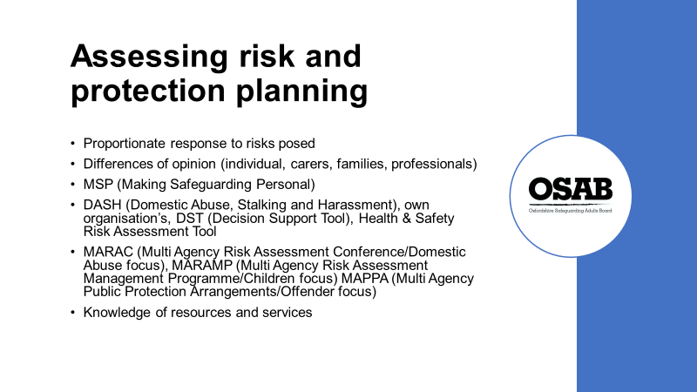

This slide is designed to break into sections the considerations when assessing risk and considering protection planning.

Proportionate response to risk posed: Do not be risk averse, and do not ignore risks.

Difference of opinion: possibly from many different people; the person, carers, families, professionals. Important to remain objective and weigh up opinions vs facts.

Making Safeguarding Personal (MSP) - having conversations with the person about how to respond in a way that enhances their involvement, choice and control, as well as improving quality of life, wellbeing and safety. Achieving a balance between wellbeing and safety is at the heart of Making Safeguarding Personal.

MARAC, MARAMP, MAPPA; all multi-agency conferences/meetings where the formally assessed risks of people in certain situations are discussed and considered in terms of options for intervention/support. The people themselves are not invited to these conferences/meetings.

Knowledge of resources and services: in terms of protection planning, it is more likely to succeed when the individual has been fully involved and has made their own decisions (even if they needed support to do this). This is especially true in terms of what support/services they may accept and engage with. As a worker, knowledge of support is available (both natural and outside support) is really important as the person may gain support they have not had previously.

Further considerations in risk assessment and protection planning:-

Protection imperative - the desire of professionals to make decisions based upon a perceived duty to protect adults from experiencing physical harm or other negative outcomes.

Influence of our own personal codes of ethics and values – this may influence professional’s judgment as to what course of action would represent ‘the best’ outcome - values such as believing that a person should live a longer life, even if it is less fulfilling, or that a person should be supported to strive for as much physical and emotional independence as possible from a parent who is perceived as enmeshing.

Balancing risks and rights – A decision to restrict an adult’s freedom is far less likely to result in a negative outcome for the practitioner or the organisation than a decision to support the taking of a risk which then goes wrong. But what about the Human Rights/choice of the individual? Supporting people to take positive risks can feel more uncomfortable for professionals/ practitioners.

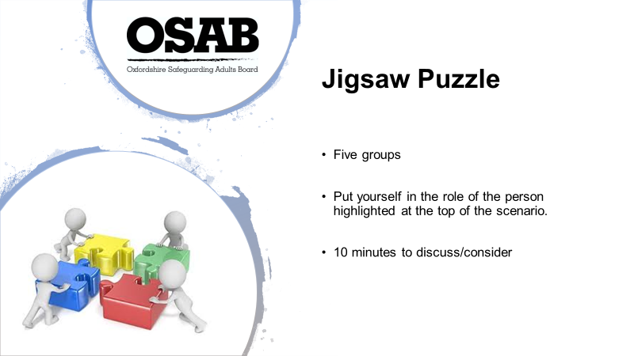

Activity:

Please ensure there are five groups. Each group is to be handed one of the pages, so each group is a different person in the scenario.

Each group is to put themselves in the role of the person highlighted at the top of the scenario. They are to consider and discuss the three points/questions on their sheets.

Give the groups 10 minutes to discuss their scenarios.

Ask each group in numerical order to read out their scenario and to feedback on the questions posed.

As each group reads out their scenario and responses, it may be that previous groups start to realise there may be more of an underlying issue than they picked up on in their scenario.

The activity is used to highlight how a situation may appear a certain way, which may be down to the person’s unconscious bias, own personal circumstances, only looking at an issue from a ‘face value’ viewpoint, rather than considering whether there are other issues arising.

Hopefully by the end of the activity, everyone will see that different professionals may have information that they have not shared as the individual worker may not have thought what was presented to them was a concern, and/or have only considered it from a narrow viewpoint. Once more information comes to light, the scenario can appear very different, and concerning, or not…?

Trainers to confirm or challenge responses given within this activity.

Examples of potential issues:
Is Jacinda’s condition deteriorating?
Gaslighting and coercive control by Alex towards Jacinda?
Depending on whether employer continues to be supportive, Jacinda could lose her job. Another element of control by Alex as Jacinda will be home and potentially more reliant on Alex?
Lesbian couple. Possibly less likely to discuss domestic abuse issues due to discriminatory attitudes?
Child protection concerns? Report to MASH.
Mr Ahmed may have memory issues. Alex may be using his bank card for her own purposes?
Volunteer is the person who potentially receives the most concerning comments. Is it for a volunteer to report? Of course it is. Safeguarding is everyone’s responsibility!

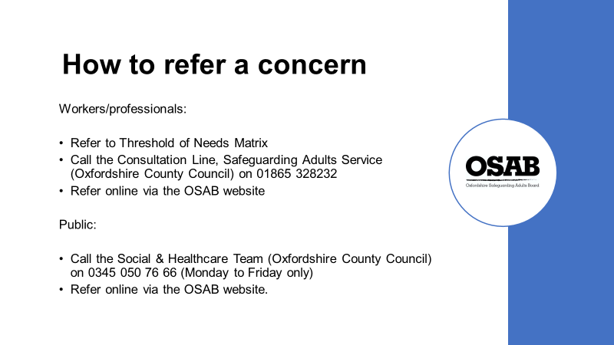

In order to consider whether a formal safeguarding concern needs to be raised with the Local Authority, workers should:-

- Refer to Threshold of Needs Matrix. If the circumstances do/do not appear to warrant raising a formal concern, always record in the person’s records that you have referred to the document and the outcome. This shows use of best practice using local procedures, which can also be useful when regulatory authorities audit organisations/companies.
- If in doubt whether to raise a formal concern call the Consultation Line. Record any conversations held.
- If a formal concern needs to be raised, go to the OSAB website and there will be a big blue box that asks “Are you concerned about an adult? Click here”. Click on it and it will take you through to the Oxfordshire County Council website and the online form. Record in your organisation’s records that you have raised a concern, and when.

If you are raising a concern as a member of the public, or a member of the public wishes to raise one, they should call the Social & Healthcare Team (Oxfordshire County Council) on the number quoted on the slide. They also have the option of completing an online form. It is the same process as described already.

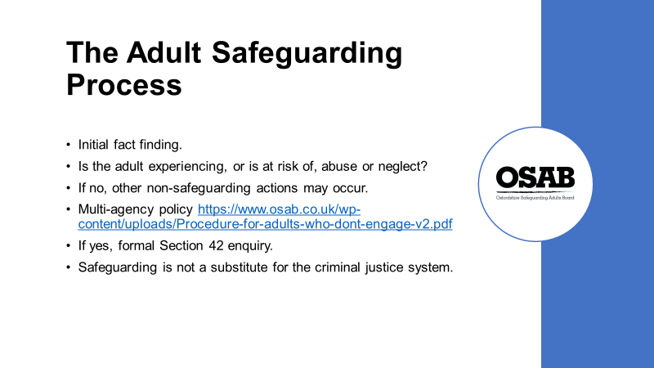

When a safeguarding concern is raised, it goes direct to the Safeguarding Adult Service (Oxfordshire County Council)

The initial stage is called ‘duty’ or ‘triage’. This is where a member of the team opens the concern and will make initial enquiries. They make contact with whoever raised the concern ‘the Referrer’ and the person who the concern is about (unless it is likely to cause the person harm by doing so)

Trainers: Please highlight the need for workers to share information with colleagues about concerns, both by keeping a written record and with a verbal handover/debrief. What happens if they are off sick the following day or go on holiday, and no-one knows what has been raised and why? It is important for the Safeguarding Adult Service to speak with the Referrer or their nominated colleague about concerns raised as soon as possible.

The Care Act 2014 (Section 42) requires that each local authority must make enquiries, or cause others to do so, if it believes an adult is experiencing, or is at risk of, abuse or neglect.

“Where the Local Authority has reasonable cause to suspect that an adult in its area (whether or not ordinarily resident there)
- has needs for care and support (whether or not the authority is meeting any of those needs),
- is experiencing, or is at risk of, abuse or neglect, and,
- as a result of those needs is unable to protect himself or herself against the abuse or neglect or the risk of it”

If the Local Authority do not consider a person is experiencing, or is at risk of abuse or neglect, then advice and information is usually given, including signposting to other potential support, i.e. assessment of needs via Adult Social Care, signposting to drug and alcohol support, housing support etc.

It is the Local Authority’s responsibility to consider whether an adult’s situation falls within Section 42 of the Care Act 2014. Referrers can assist in this area by noting all ‘vulnerabilities’ and ‘indicators’ a person has (remind attendees of the earlier discussions during this session around these points). This will help to build a picture of the person and their circumstances.

There is a multi-agency policy “Working with people who do not engage with services/or are
deemed ineligible to receive services” which can be found on the OSAB website https://www.osab.co.uk/wp-content/uploads/Procedure-for-adults-who-dont-engage-v2.pdf This can be a useful guide in terms of gaining engagement from other organisations when there are concerns about an adult.

A Section 42 enquiry should establish whether any action needs to be taken to prevent or stop abuse or neglect, and if so, by whom.

A Police investigation will take precedence over safeguarding investigations, but risk assessment and reduction of harm or support for the victim is still applicable and should not wait!

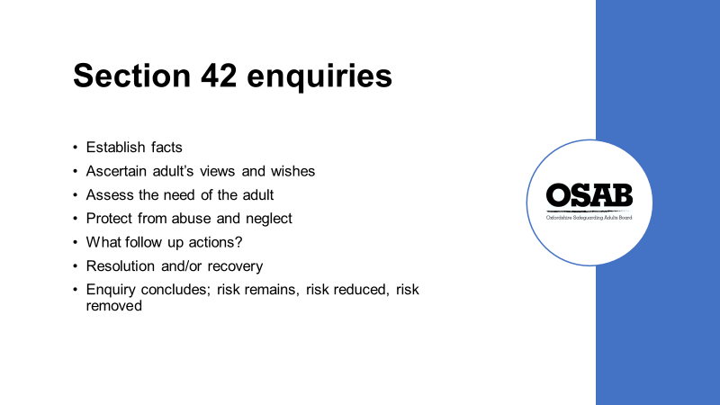

The Care Act 2014 (Section 42) requires that each local authority must make enquiries, or cause others to do so. Therefore, although the Local Authority would oversee and hold overall responsibility for any enquiry, it may pass the enquiry another organisation to gather relevant information, for example, Oxford University Hospitals (if the person was in hospital at the time of the alleged abuse occurring, or are in hospital following alleged abuse occurring in their home environment, so can be spoken to whilst in hospital)

The objectives of a Section 42 enquiry are to:-

Establish facts - What is the concern? What is/are the risk/s? What is the level of risk to the person/s? Has anything been done to reduce any immediate risks? Etc

Ascertain the adult’s views and wishes - Making Safeguarding Personal (MSP). Does the person understand why there is a concern? What are their views on the situation? Do they feel safe? Do they want anything to change?

Assess the needs of the adult for protection and support, and how this might be met – Does the person need protection/support? Are they able to manage the potential risks themselves or by using their natural support network? An example of support may be, giving information i.e. Domestic Abuse helpline, to a formal assessment of needs that results in formal carers put in place to provide care rather than informal carer who may have been perpetrating the abuse (PLEASE NOTE: these are a couple of examples, not what always happens! Every person’s circumstances differ)

Protect from abuse and neglect in accordance with the wishes of the adult - safeguarding cannot be ‘done’ to an adult, it should always be carried out in accordance with their wishes, or in their ‘Best Interests’ under the Mental Capacity Act 2005.

Make decisions as to what follow-up actions should be taken with regards to the person or
organisation responsible for abuse or neglect – this could include; criminal proceedings, formal care providers being put on a Serious Concerns List with Local Authority.

Enable the adult to achieve resolution and recovery from the experience of abuse or neglect. This is not always possible. Sometimes the person does not want any support etc.

Enquiry concludes with action that has been taken (or not). Conclusions can be risk remains, risk reduced, or risk removed.

It is not always clear what should be appropriately considered a safeguarding issue and addressed through a safeguarding enquiry and what should be more appropriately dealt with through other routes including complaints, employment law, contract monitoring and compliance, regulation and quality improvement processes. All these routes, used effectively, will safeguard people.

The important point is for all options to be considered, recorded and co-ordinated and for the best interests of the person who has been abused to always be at the forefront of people’s minds.

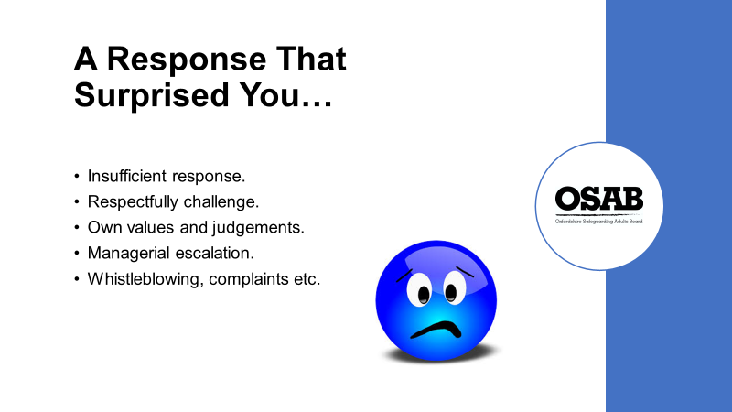

What to do if you receive an insufficient response from organisations and/or agencies? Initially go back to the person who informed you of the decision. If you are still not satisfied with the response, ask to speak with their senior. It is useful to gain a response as to why a no has been given (if that is the case) and potentially to have some information about where to go next (if applicable)

Do you have the confidence to respectfully challenge others, either within your own organisation or in another? Providing your focus is on the individual, and you are not challenging just because a decision does not fit with what works best for you in your role, then challenge is appropriate.

Sometimes responses from others/organisations can challenge our own values and judgements. We may not realise we have made a judgement or have been driven by a personal bias, for example, we may have certain views of organisations and services that mean we are defensive in our approach and when we receive a ‘no’ it may feed into our confirmation bias (the tendency to search for, interpret, favour, and recall information in a way that affirms one's prior beliefs or hypotheses).

Within organisations, you should be able to escalate any concerns you have about a response via managerial escalation. This is also true of other organisations/services. As stated previously, you can escalate concerns via the person’s management.

Whistleblowing, complaints, professional bodies. There are also more formal ways of escalating your concerns, including:-

Whistleblowing – as a worker, you can report certain types of wrongdoing. This will usually be something you’ve seen at work - though not always. The wrongdoing you disclose must be in the public interest. This means it must affect others, for example the general public. As a whistle blower you’re protected by law in terms of detrimental treatment by your employer (The Public Interest Disclosure Act 1998). You should not be treated unfairly or lose your job because you ‘blow the whistle’.

Your organisation should have a Whistleblowing policy that you should refer to in the first instance.

Complaints -. all organisations should have complaints and compliments procedures. If you wish to raise a formal complaint about a worker in an organisation you should refer to the organisations complaints procedures (may be known as compliments and complaints)

Professional bodies – the professional and their organisation should be contacted in the first instance to resolve any issues. If unresolved, and people feel a strong need to contact the professional body, they can do so.

Examples of professions and the professional body to which they are registered:-

- Art Therapists, Chiropodists/Podiatrists, Social Workers, Occupational Therapists and other professions should be registered with the Health & Care Professions Council (HCPC)

- Nurses, Midwives and Nursing Associates should be registered with the Nursing & Midwifery Council (MWC)

- General Practitioners (GPs) should be registered with the General Medical Council (GMC)

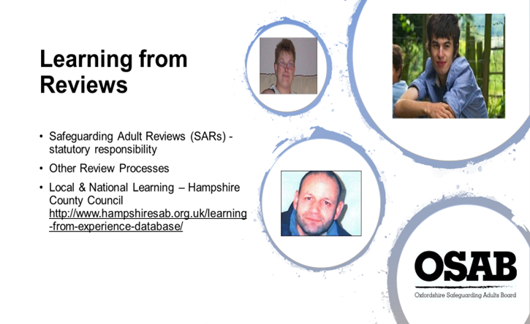

Having discussed what should happen in terms of best practice/joint working to safeguard an adult at risk of abuse or neglect, we now come to focus on Safeguarding Adults Reviews (SARs).

Under Section 44 of the Care Act 2014, all Safeguarding Adult Boards have a statutory duty to conduct Safeguarding Adult Reviews (SARs) when there has been a death or life-changing injury to a person with care and support needs and there are concerns over how agencies worked together to help that person. SARs are a process for all partner agencies to identify the lessons that can be learned from particularly complex or serious safeguarding adult cases. With the objective being to promote learning and improve practice, not to re-investigate or apportion blame. They are designed to improve services and present future deaths or serious harm occurring again.

A report is produced which document the findings and recommendations. SARs in Oxfordshire that are published can be found on OSAB’s website.

Hampshire County Council have a Learning from Experience database where you can read Safeguarding Adult Reviews and previous Serious Case Reviews (under which you can search via Theme, Local Authority Area and Year) http://www.hampshiresab.org.uk/learning-from-experience-database/

Many SAR’s undertaken Nationally have highlighted the lack of information sharing/poor communication between partners who did not take a joined-up approach to safeguarding people (refer back to the Jigsaw Puzzle activity if it highlighted where opportunities to share information was missed)

Trainers: Ask attendees if they can name the three people whose photographs are on the slide.

It is likely that people will be able to name Connor Sparrowhawk (top right circle) 18, who was diagnosed with autism aged three, had learning difficulties and developed epilepsy, having his first seizure in January 2013. Connor died in July 2013 while he was in the care of Southern Health NHS Foundation Trust. An independent report concluded that Connor’s death was preventable and that there were significant failings in his care and treatment.

Trainers: further reading https://www.inquest.org.uk/connor-sparrowhawk-inquest-conclusions and https://www.england.nhs.uk/wp-content/uploads/2015/10/indpndnt-rev-connor-sparrowhawk.pdf

In the top left-hand circle is a photograph of Gemma Hayter, 27. Gemma’s family long suspected she had a learning disability, but she was without a formal diagnosis. Gemma was ‘befriended’ by a group of people who used her to look after drugs in her flat. Those ‘friends’ eventually murdered her.
Trainers: further reading https://www.safeguardingwarwickshire.co.uk/images/downloads/SCR-of-Gemma-Hayter.pdf
https://www.bbc.co.uk/bbcthree/article/751ddfd4-2b7a-4f3f-9a07-2f2ec29c985a

In the bottom left-hand circle is a photograph of Stephen Hoskin, 39, who had a Learning Disability, was subjected to “harrowing” abuse by people who ‘befriended’ him. It ended in his death in St Austell, Cornwall on 6 July 2006. He was forced to swallow a lethal dose of paracetamol, hauled around his bedsit by a dog collar and burned with cigarettes. He was made to hold onto a railing on a viaduct and had his hands stamped on where he dropped 100ft to his death. His body was found at the base of the St Austell railway viaduct. His murder has since been described as a 'disability hate crime'

Trainers: further reading https://www.cornwall.gov.uk/media/3633936/Steven-Hoskin-Serious-Case-Review-Exec-Summary.pdf

The circumstances surrounding both Gemma and Stephen’s deaths were held under Serious Case Review processes as they happened prior to the Care Act 2014 (Section 44 covers Safeguarding Adults Boards must hold Safeguarding Adult Reviews if certain conditions are met)
Trainers: further reading http://www.legislation.gov.uk/ukpga/2014/23/part/1/crossheading/safeguarding-adults-at-risk-of-abuse-or-neglect/enacted

Other review processes:-

Domestic Homicide Reviews (DHRs) – are multi-agency reviews of the circumstances in which the death of a person aged 16 or over has, or appears to have, resulted from violence, abuse or neglect by a person to whom they were related or with whom they were, or had been, in an intimate personal relationship, or a member of the same household as themselves.

Multi-agency Public Protection Arrangements (MAPPA) Serious Case Review - is the process through which various agencies such as the police, the Prison Service and Probation work together to protect the public by managing the risks posed by violent and sexual offenders living in the community

Multi-agency Risk Assessment Conference (MARAC) - A Multi Agency Risk Assessment Conference (MARAC) is a victim focused information sharing and risk management meeting attended by all key agencies, where high risk cases are discussed. The role of the MARAC is to facilitate, monitor and evaluate effective information sharing to enable appropriate actions to be taken to increase public safety. Further information can be found at www.reducingtherisk.org.uk/cms/content/marac

Vulnerable Adult Mortality Reviews (VAM) - Oxfordshire Safeguarding Adults Board (OSAB) set up the Oxfordshire Vulnerable Adult Mortality Group (VAM). The VAM reviews the deaths of every person (including children and young people) with a learning disability in Oxfordshire, unless there is a review already being carried out by another organisation (e.g. a coroner’s review). The VAM reports to OSAB and to the national Learning Disability Mortality Review (LeDeR) programme.

Mental Health Homicide Reviews - In April 2013 NHS England became responsible for commissioning independent investigations into homicides (sometimes referred to as mental health homicide reviews) that are committed by patients being treated for mental illness. The purpose of an independent investigation is to review thoroughly the care and treatment received by the patient so that the NHS can:

- Be clear about what – if anything – went wrong with the care of the patient
- Minimise the possibility of a reoccurrence of similar events
- Make recommendations for the delivery of health services in the future

An independent investigation is carried out separately from any police, legal and Coroner’s proceedings. It is done by an independent, expert organisation, which is given access to all the information and reports about the individual patient’s care and treatment (within the usual patient confidentiality rules), and who can also request interviews with any NHS staff involved.

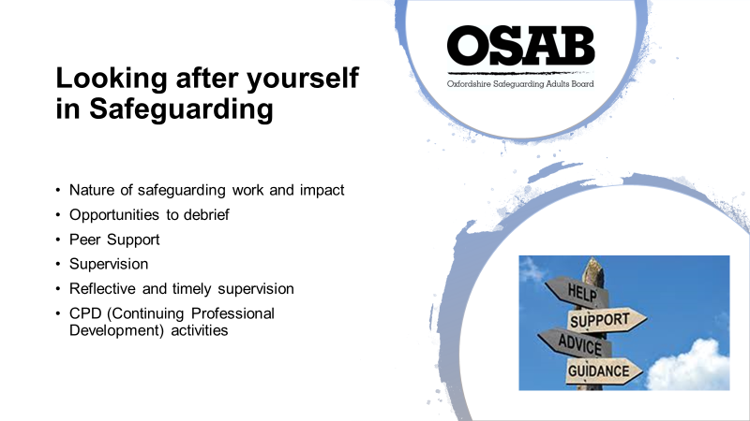

The emotionally charged nature of the work can place particular demands on workers in the field. An incident may have occurred and may not register with you at the time, but later you may have an emotional and/or physical reaction to it.

Debriefing – do you have someone you can contact in your organisation to talk about what has happened? Is this immediate if required, or could you be waiting some time?

Peer support – what kind of peer support do you have? Are you able to discuss matters with colleagues and receive support as and when you need it?

Supervision should be timely and protected (not dismissed as not important!) Your organisation may put supervision in once a month, is this flexible if you require it sooner?

Supervision should be reflective in terms of your practice, assist with making decisions, assessing risks (consideration of the concerns) and should improve the quality of your practice. Not something that is just put in a calendar and either cancelled regularly at short notice, or just used as a tick box exercise.

CPD – Continuing professional development. Attending training sessions can be useful in order to take a step away from your daily work and focus on a subject matter for a protected time. Are you offered time to undertake reading in relation to your work? Do you find yourself watching tv programmes that relate to the type of work you undertake? All of this is professional development. Always keep a note of what you have undertaken as it shows you have up to date knowledge and skills, which will support your work with people and ultimately could help you move to another job!

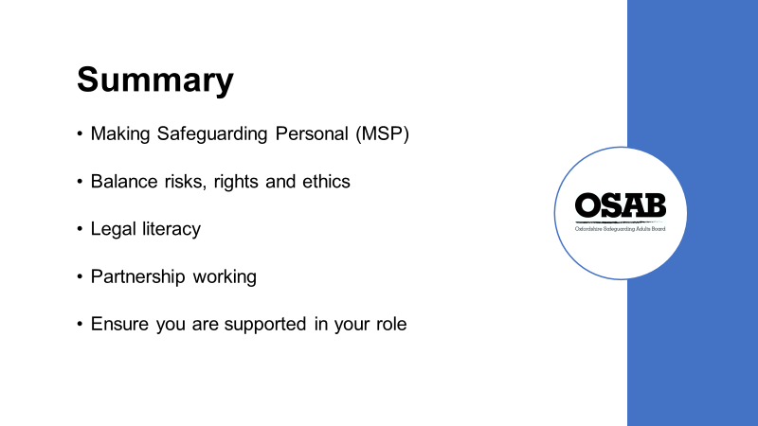

This is the final slide. It gives you the opportunity to summarise and recap on the content of the training session.

It is for you to decide how you present this final slide, but it is good to finish on a summary.

If there is time, ask attendees whether they have any further questions before they leave.

Please check that everyone has signed the register. Inform attendees that they need to log into their OSAB account to complete an evaluation form. Once completed, they will then have the opportunity to download their Certificate of Attendance.

Please remind attendees that evaluation forms are read, and comments are considered in terms of any changes to the training that may be required and affords feedback for Trainers on their delivery of the training.

END OF SESSION

And finally…

THANK YOU for being a Trainer for Oxfordshire Safeguarding Adults Board. I hope the delivery of sessions go well and they are enjoyable experiences for you.

Regards,

Helen Kershaw
Learning & Engagement Officer,
Oxfordshire Safeguarding Adults Board

