Level 3 Lead/Manager Course
Trainer Handbook

Duration: 3.5 hours

This course has been designed for people with leadership or management responsibilities for workers who are working directly with adults, and/or are the named lead or designated professional for their organisation or setting.

The training is offered via OSAB as multi-agency training and is delivered via our pool of trainers from agencies who work in the field of adult safeguarding.

Level 3 Lead/Manager training is valid for up to 3 years.

Target audience:

All staff who regularly investigate and/or contribute to supporting adults at risk of abuse and/or their families/carers, and who manage or supervise staff who do. This includes through multi-agency safeguarding procedures and assessing, planning, intervening and evaluating the needs of an adult where there are safeguarding concerns.

OSAB Contact:

Helen Kershaw, Learning & Engagement Officer
07747 008 359
Helen.kershaw@oxfordshire.gov.uk please also cc to osab@oxfordshire.gov.uk

Contents Page

Slide Title | Page Number | Time/Minutes
Title Page / Aims and Objectives | 3
Housekeeping, training agreement & introductions | 4/5 | 15 mins – 9.30 to 9.45
Your role as Managers/Leads | 6/7 | 5 mins – 9.45 to 9.50
How to refer a concern | 8
The adult safeguarding process | 9/10 | 10 mins – 9.50 to 10.00
What happens next? | 10
Legal awareness and literacy | 11/12/13 | 15 mins – 10.00 to 10.15
Mental Capacity Act | 13/14 | 10 mins – 10.15 – 10.25
Confidentiality, information sharing & consent | 15/16 | 10 mins – 10.25 to 10.35
Information sharing | 16/17
Supporting assessing risk & protection planning | 18/19 | 10 mins – 10.35 to 10.45
MARAC | 19 | 5 mins – 10.45 to 10.50
MAPPA | 20
BREAK | 21 | 10/15 mins – 10.50 - 11.05
Case Study Activity | 21/22 | 40/45 mins – 11.05 to 11.45/11.50
Allegations of abuse by professionals/staff | 22/23/24 | 15 mins (includes) YouTube clip – 11.50 to 12.05
Duty of Candour | 25
Reviewing safeguarding practice | 26 | 5 mins – 12.05 to 12.10
Escalating a concern | 27 | 5 mins – 12.10 – 12.15
Learning from Reviews | 28/29
Learning from SAR’s – Oxfordshire | 30 | 15 mins – 12.15 to 12.30
Learning from SAR’s – National | 31
Roles and procedures | 32 | 10 mins – 12.30 to 12.40
Any questions about the session? | -- | 5/10 mins – 12.40 – 12.45 to 12.50
Summary | 33 | 5 mins – 12.50 to 12.55
END OF SESSION

Trainers notes

Please put enough copies of the Threshold of Needs Matrix on each table before the start of the session. They will be referred to during the slide ‘How to refer a concern’ and should be referred to during the case study activity further on in the session.

Please note there is a YouTube clip to be played when at the slide entitled ‘Allegations of abuse by professionals/staff’. Please therefore ensure this is set up before starting the session, so it is ready to be accessed when needed.

Please note that timings are there as a guide. Trainers to keep an eye on timings and gauge when discussions need to end, in order to move on.

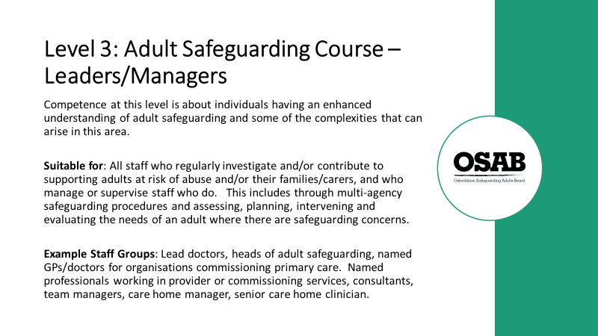

This slide explains the level of the course and who would benefit from attending.
No explanation is required. Have this slide showing as people come into the room, prior to the start of the session.

When ready to start, it is worth just checking that everyone is expecting to attend Level 3 Awareness (Leaders/Managers) training, as opposed to anything else!

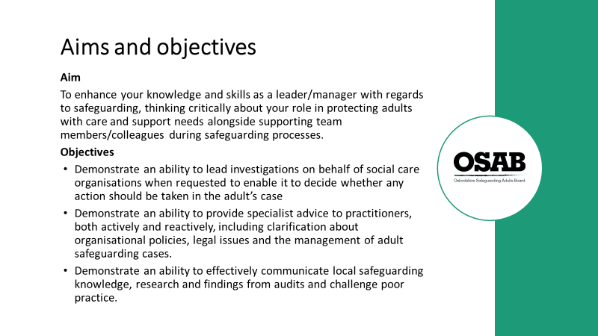

Ask delegates to view the aim and objectives of the training and check that people are happy with the course overview.

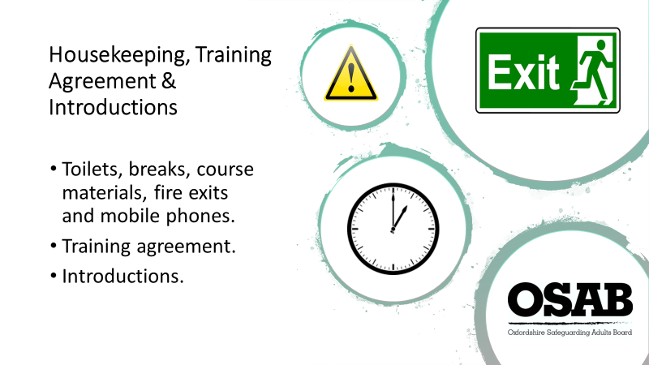

Please ensure you know where toilets and fire exits are located, whether any ‘tests’ are due in terms of fire drills etc., and where you would need to congregate if an alarm goes off.
Course timings – 3.5 hours in length, a break of 10 minutes. If anyone needs a comfort break of any kind during the session, they are free to do so and do not have to ask Trainers!
Course materials – the joining email will have stated copies of slides and further information will be sent after the course today, but please remind people of that. NOTE: Please ensure everyone has signed the register as they will be marked as not attending if they do not.
Mobile phones: Switched to vibrate or silent. If anyone needs to take calls please leave the training room to do so and return to the session if they are able to. NOTE: Please ask people not to sit on phones checking their social media accounts. They will be called out if they do!

Key points:
Encourage participation by all as it makes for a more enjoyable and memorable training experience. It may be useful to explain that training in a multi-agency environment better assists people to gain understanding of different perspectives, and professional expertise.

Referring to each member has a valid contribution
Explain that safeguarding adults is about sharing information and working together. For example, some agencies/workers will be involved with an adult only at the point of crisis, and others may have long standing relationships with adults before safeguarding issues are raised. All professionals/workers and individuals are important, and only be working together do we see good practice and outcomes for adults.

Learning is about participation and positivity
As safeguarding is everyone’s responsibility, it is useful to mention that it is about workers feeling confident about safeguarding and this course aims to ensure that a difficult subject is considered with sensitivity and positivity. NOTE: this really depends on your training style, but effective learning should be fun and not restrictive in its message.

Encourage people to ask for clarifications and question when they don’t understand or don’t agree. Remind people that participants will have a varying degree of experience in safeguarding and any challenge should be respectful.

Trainers should ask delegates to be mindful of jargon and to explain any abbreviations.

Multi-agency issues may be discussed but should be done so professionally…
Sensitivity and support for each other is important both in group training and at work. Personal backgrounds and experiences will be varied and all have different valuable perspectives to draw upon. Any agency barriers that arise will be addressed; however, all delegates must be made to feel welcome and at no stage should be a ‘target’ for any agency barriers. Delegates should also be asked to be sensitive in how points are made when discussing other agencies.

Support the principality of confidentiality
Remember to speak about confidentiality. Discussion within the group is confidential unless the Trainer deems there has been a disclosure that puts an adult/adults, the delegate/professional or the Trainer at risk. In this cases the Trainer has an obligation to report it.

Identify that it is likely that real cases may be utilised but confidentiality should be maintained; therefore, no names, colleagues or clients details should be mentioned. Real cases are used to help make training more realistic and to help focus on certain elements. Members may recognise some of the information used and should they at any stage feel aspects are not being correctly represented, they should speak to the Trainers.

REMEMBER: this course covers some very emotive areas so remind delegates that if they’re struggling with any issues the course raises, they can take time out or speak to the Trainer during a break/at the end of the course.

Introductions - Trainers should describe their own role and the organisations they work for. This helps to establish their credibility as someone to present on safeguarding (don’t forget add-ons to your role such as being a Best Interest Assessor, AMHP etc.)

Next ask the delegates to introduce themselves to the whole group (not just the Trainers!). It would be good to hear their name (doesn’t have to be full name!), what their job role is and which organisation they work for (no acronyms please) and the work/people the organisation do/work with.

It is here that it is useful highlight how networking with each other helps us to gain an understanding what support is available for people etc.

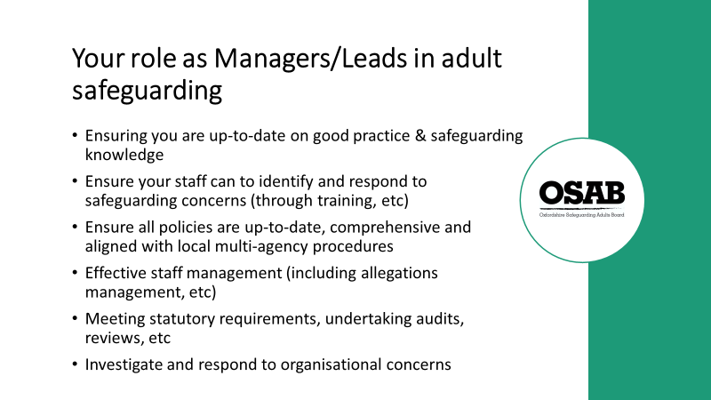

Trainers, please start with the statements in the two following paragraphs (obviously in your own words)

There is an expectation on this training that as Managers/Leads (M/L) in adult safeguarding within their own organisations/companies, they will have worked experience and a good baseline knowledge around adult safeguarding, to include (but not limited to) types and indicators of abuse, what should be reported, and how to report a formal safeguarding concern.

Please acknowledge that the training is multi-agency, so the remits of people’s roles are likely to vary, for example, some may work in large organisations where they may be less likely to be involved in writing and reviewing policies (as there may be specific departments that deal with this), as opposed to someone who is an owner manager/Trustee of an organisation/company, who may undertake this task. The training cannot cover everything, but it does attempt to cover many different aspects of people’s Lead/Manager roles.

- It is important L/M have up to date knowledge of best practice which will include (but not limited to); local multi-agency procedures, own organisations/company’s policies around adult safeguarding, understanding Making Safeguarding Personal and how the outcomes identified by the service user should be reflected within the adult safeguarding process, understanding of how abuse may affect individuals’ decision-making processes e.g. Domestic violence, understand the co-ordinating role in relation to different types of enquiry that may be taking place simultaneously.

- Ensuring your staff can respond to safeguarding concerns, this may be through attendance at formal training events, peer supervision, peer discussions, a bite-sized learning event within team meetings. This also includes overseeing their work in this area to ensure any learning is being implemented.

- All policies should be relevant and useful to those they apply to. Do your staff know what policies are relevant to their roles? Do they know where to find them? Are they pinned on a notice board, not having been updated for several years? Multi-agency procedures are on the OSAB website www.osab.co.uk, for example, procedure for adults who don’t engage or meet criteria www.osab.co.uk/wp-content/uploads/Procedure-for-adults-who-dont-engage-v2.pdf, Oxfordshire multi-agency self-neglect policy www.osab.co.uk/wp-content/uploads/Oxfordshire-self-neglect-policy-v1.pdf These policies and procedures are designed to offer support to organisations/companies when faced with adult safeguarding concerns.
- Do staff carry out lone working in the community? How do you oversee their work? Are spot checks carried out of their visits to people? Are formal meetings/supervisions undertaken with staff? How do you ensure staff are using best and safe practices with people? Do you lead by example? How approachable are you as Leads/Managers? Are you confident in dealing with allegations against staff?

- Statutory requirements not only cover the undertaking of audits and reviews of practice, but they pertain to, for example, all health care organisations having a duty outlined in legislation to make arrangements to safeguard and to co-operate with other agencies to protect adults at risk from harm abuse or neglect. Chief executive officers have a responsibility to seek assurance that all staff are able to meet this requirement (taken from www.rcn.org.uk/-/media/royal-college-of-nursing/documents/publications/2018/august/pdf-007069.pdf)
The Care Act 2014 sets out a clear legal framework for how local authorities and other parts of the system should protect adults at risk of abuse or neglect. Local authorities have safeguarding duties. They must:
  - lead a multi-agency local adult safeguarding system that seeks to prevent abuse and neglect and stop it quickly when it happens
  - make enquiries, or request others to make them, when they think an adult with care and support needs may be at risk of abuse or neglect and they need to find out what action may be needed
  - establish Safeguarding Adults Boards, including the local authority, NHS and police, which will develop, share and implement a joint safeguarding strategy
  - carry out Safeguarding Adults Reviews when someone with care and support needs dies as a result of neglect or abuse and there is a concern that the local authority or its partners could have done more to protect them
  - arrange for an independent advocate to represent and support a person who is the subject of a safeguarding enquiry or review, if required.
Any relevant person or organisation must provide information to Safeguarding Adults Boards as requested (taken from www.scie.org.uk/care-act-2014/safeguarding-adults/)

- Concerns may be raised around practice within your own organisation/company. The primary aim of any procedures for dealing with safeguarding concerns (including organisational abuse) is that the well-being and best possible outcomes for the individual is of the highest priority for all the agencies concerned.
Organisational abuse is the mistreatment or abuse or neglect of an adult at risk by a regime or individuals within settings and services that adults at risk live in or use, that violate the person’s dignity, resulting in lack of respect for their human rights. Organisational abuse occurs when the routines, systems and regimes of an organisation result in poor or inadequate standards of care and poor practice which affects the whole setting and denies, restricts or curtails the dignity, privacy, choice, independence or fulfilment of adults at risk.

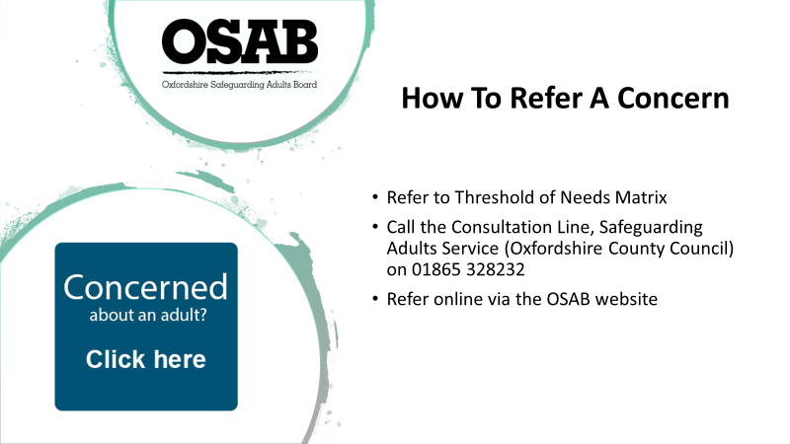

This slide and the next two are designed to act as an informative recap, but for some attendees, they may not have worked in Oxfordshire previously, or just don’t know how to refer, so please offer an explanation of how to use the Threshold of Needs Matrix. Emphasise the Consultation Line as a tool for discussion and support.

In order to consider whether a formal safeguarding concern needs to be raised with the Local Authority, workers should:-

• Refer to Threshold of Needs Matrix. If the circumstances do/do not appear to warrant raising a formal concern, always record in the person’s records that you have referred to the document and the outcome. This shows use of best practice using local procedures, which can also be useful when regulatory authorities audit organisations/companies.
• If in doubt whether to raise a formal concern call the Consultation Line. Record any conversations held.
• If a formal concern needs to be raised, go to the OSAB website and there will be a big blue box that asks “Are you concerned about an adult? Click here”. Click on it and it will take you through to the Oxfordshire County Council website and the online form. Record in your organisation’s records that you have raised a concern, and when.

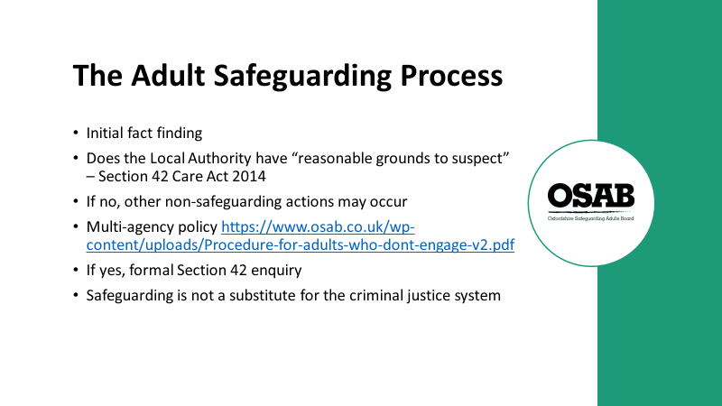

When a safeguarding concern is raised, it goes straight to the Safeguarding Adult Service (Oxfordshire County Council)

The initial stage is called ‘duty’ or ‘triage’. This is where a member of the team opens the concern and will make initial enquiries. They make contact with whoever raised the concern ‘the Referrer’ and the person who the concern is about (unless it is likely to cause the person harm by doing so)

Trainers: Please highlight the need for workers to share information with colleagues about concerns, both by keeping a written record and with a verbal handover/debrief. What happens if they are off sick the following day or go on holiday, and no-one knows what has been raised and why? It is important for the Safeguarding Adult Service to speak with the Referrer or their nominated colleague about concerns raised as soon as possible.

Part of the initial fact-finding stage is to ascertain whether the Local Authority has reasonable cause to suspect that an adult in its area (whether or not ordinarily resident there)

“a) has needs for care and support (whether or not the authority is meeting any of those needs),
b) is experiencing, or is at risk of, abuse or neglect, and,
c) as a result of those needs is unable to protect himself or herself against the abuse or neglect or the risk of it”

If the Local Authority does not have reasonable cause to suspect the above (a,b,c), for which there can be several reasons for this, i.e. the person may not have care and support needs, or may be able to protect themselves, then advice and information is usually given, including signposting to other potential support.

It is the Local Authority’s responsibility to consider whether a person has care and support needs, or not. Workers can assist in this area by noting all ‘vulnerabilities’ and ‘indicators’ a person has (remind attendees of the earlier discussions during this session around these points).

There is a multi-agency policy “Working with people who do not engage with services/or are
deemed ineligible to receive services” which can be found on the OSAB website https://www.osab.co.uk/wp-content/uploads/Procedure-for-adults-who-dont-engage-v2.pdf
This can be a useful guide in terms of gaining engagement from other organisations.
A Police investigation will take precedence over safeguarding investigations, but risk assessment and reduction of harm or support for the victim is still applicable and should not wait!

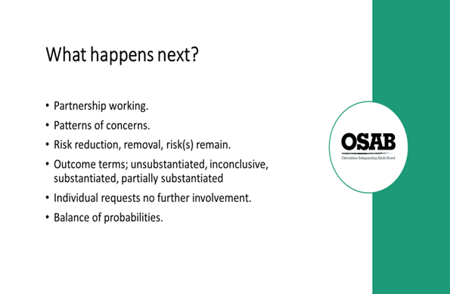

Purpose of a safeguarding adult’s enquiry (Section 42 of the Care Act 2014) is to decide what action is needed to help and protect the adult(s) at risk of abuse.

Partnership working – very important in the safeguarding process. Working in partnership with care providers and other partner agencies so that the best outcomes for people who use care and support services are achieved.

Patterns of concerns – these can be picked up when multiple concerns are raised about the same provider/perpetrator. Your organisation/company may pick up on themes, who do these concerns get reported to? It is just something that is known and not more widely shared? For example, Police can be called on 101, with information used as ‘soft intelligence’.
If the Safeguarding Adults Service become aware of patterns/themes, they will speak with the Contracts Department and the Care Quality Commission with regards to concerns and findings.

Risks – safety planning can be implemented and the outcome can be; risk reduction, removal of risk or risk(s) remain. We will talk about risk assessment later on.

Outcome terms – these are terms that are used when a Section 42 enquiry has been concluded. All findings that relate to a provider of services will be forwarded to the Care Quality Commission.

If an individual has capacity to make a decision about the safeguarding enquiry and doesn’t want further involvement, organisations/agencies/companies have to agree with that (providing legal literacy, responsibilities etc. have been considered and documented!) This does not mean that should a concern arise again about the person, that a new concern is not raised, it should be.

Balance of probabilities – safeguarding enquiries are not Police investigations, i.e. do not have to prove beyond all reasonable doubt, they have to consider the balance of probabilities that events occurred.

There may be ongoing work with other agencies even if a safeguarding enquiry has been closed. MARAC (Multi-agency risk assessment conference/domestic abuse/violence focus) is an example of this (to be explained on a later slide)

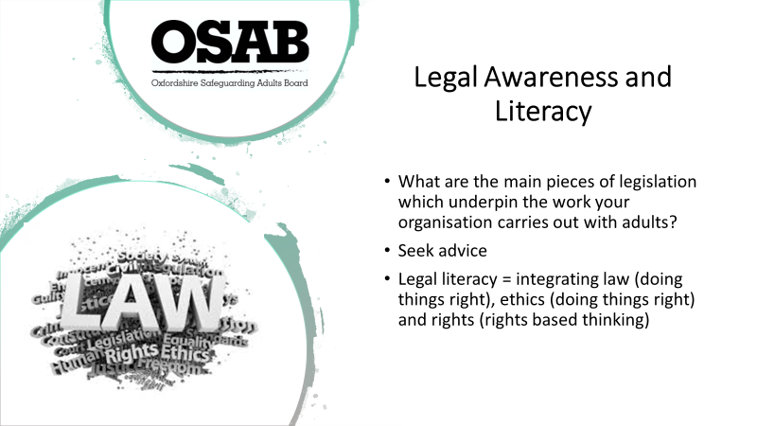

Trainers to ask the question on the slide. Ask attendees to work in small groups to discuss. Please bear in mind that if people are sat with their work colleagues, this activity will not work as well. Ask people to turn around/move in order to discuss with people that may work in a different environment. Give 5 minutes for discussions to take place.

Trainers to seek feedback - How did the discussions go? Did everyone find that they used differing pieces of legislation? Where there overlaps? Which Acts came up?

This is not designed to be a lengthy discussion about the law but should be used to highlight the different pieces of legislation that organisations draw upon in their work with adults, for example, the Local Authority may refer to The Homelessness Reduction Act 2017 which introduced a duty on certain public authorities to refer service users who they think may be homeless or threatened with homelessness to a housing authority. The person must give consent and can choose which authority to be referred to. The housing authority should incorporate the duty to refer into their homelessness strategy and establish effective partnerships and working arrangements with agencies to facilitate appropriate referrals.

A Housing Officer may refer to Part 6 of the Housing Act 1996 which regulates the allocation of social rented housing by local authorities. Part 6 was amended by the Homelessness Act 2002, and, with effect from 18 June 2012, by the Localism Act 2011. The Localism Act gives local authorities greater power to decide which categories of person they will allocate accommodation to.

These pieces of legislation are designed to offer support around Housing need, with one being a duty to refer and another being the power to decide who will be allocated accommodation.

Other pieces of legislation that may be called out are:-

Care Act 2014 – which consolidated many different laws around Adult Social Care. It sets out the Local Authority’s duties around assessment and eligibility - Section 1 duty to promote wellbeing. Section 42 sets out the local authority’s duty to make safeguarding enquiries. Section 43 requires every Local Authority to establish a Safeguarding Adults Board (SAB) for its area. The SAB operates at a strategic level, helping and protecting adults in its area from abuse and neglect through co-ordinating and reviewing a multi-agency approach across all member organisations. Section 67 of the Care Act 2014 (“the Act”) imposes a duty on local authorities to arrange for an independent advocate to be available to represent and support certain persons for the purpose of facilitating those persons' involvement in the exercise of functions by local authorities
Mental Capacity Act 2005 – are people able to make specific decisions for themselves? If they are not, how and when decisions can/should be made in their ‘Best Interests’. Section 44 of the MCA prioritises people’s safety by making wilful neglect or mistreatment of an adult who lacks capacity to make decisions a criminal offence.
Mental Capacity (Amendment) Act 2019 will introduce Liberty Protection Safeguards to replace Deprivation of Liberty Safeguards. Likely timeframe of October 2020.
Human Rights Act 1988 - sets out the fundamental rights and freedoms that everyone in the UK is entitled to, set out in a series of ‘Articles’, for example; Article 3: Freedom from torture and inhuman and degrading treatment; Article 4: freedom from slavery and forced labour, Article 8: respect for your private and family life, home and correspondence.
Mental Health Act 1983 (amended 2007) – is the main piece of legislation that covers the assessment, treatment and rights of people with a mental health disorder. People detained under the Mental Health Act need urgent treatment for a mental health disorder and are at risk of harm to themselves or others. The 2007 amendment brought about extended powers of compulsion in the community – Supervised Community Treatment (SCT) – and a widening of the professional groups that could apply to fulfil roles that exercise power under the Act – Approved Mental Health Professional (AMHP) and Responsible Clinician (RC).
Modern Slavery Act 2015 – a law that consolidated previous legislation. It’s designed to tackle slavery and trafficking in the UK.
Anti-social Behaviour, Crime & Policing Act 2014 - designed to target crime and anti-social behaviour. 1998 Crime & Disorder Act created the ASBO. Forced marriage offences are covered under Section 121 of the Anti-Social Behaviour, Crime and Policing Act 2014
Serious Crime Act 2015 – designed to ensure that the National Crime Agency, the police and other law enforcement agencies can continue effectively and relentlessly to pursue, disrupt and bring to justice serious and organised criminals. Section 76 created an offence of controlling or coercive behaviour in an intimate or family relationship.
Equality Act 2010 - The Equality Act 2010 legally protects people from discrimination in the workplace and in wider society. It replaced previous anti-discrimination laws with a single Act, making the law easier to understand and strengthening protection in some situations. It sets out the different ways in which it’s unlawful to treat someone, and who has a right to challenge discrimination. It puts a responsibility on public authorities to have due regards to the need to eliminate discrimination and promote equality of opportunity.
Data Protection Act 2018 and General Data Protection Regulations (GDPR) – controls how your personal information is used by organisations, businesses or the government.
Safeguarding Vulnerable Groups Act 2006 - designed to help avoid harm, or risk of harm, by preventing people who are deemed unsuitable to work with children and vulnerable adults from gaining access to them through their work. Organisations/companies with responsibility for providing services or personnel to vulnerable groups have a legal obligation to refer relevant information to the Disclosure and Barring Services (DBS).

This list is not exhaustive. There are many pieces of legislation that underpin work with adults.

Seek advice - If in any doubts around what legislation may be relevant in terms of safeguarding concerns of an adult, or how to implement specific pieces of legislation, guidance should always be sought. Initially within your own organisation/company. If there is another organisation that may have specialist knowledge in a certain area, give them a call and ask.

Legal literacy is very important. Technical knowledge of law alone is not enough. Legal rules must be interpreted and applied in complex human situations in which professional ethics and human rights principles also underpin professional practice. This skilled exercise of professional judgement, which integrates law (doing things right), ethics (doing right things) and rights (rights-based thinking), can be called legal literacy.

Knowledge of case law is useful. Some examples of where to find case law:-
Research in Practice for Adults (RiPfA) https://www.ripfa.org.uk/ organisations must sign up to be members of RiPfA.
Local Government Ombudsman https://www.lgo.org.uk/decisions
39 Essex Chambers https://www.39essex.com/
Housing Rights https://www.housingrights.org.uk/category/case-law

Inherent Jurisdiction of The High Court may come up. Further reading of the most recent case law can be found at https://www.39essex.com/cop_cases/southend-on-sea-borough-council-v-meyers/
Summary: the dilemma before the court was what, if anything, could be done to secure the interests of a 97 year old man with physical disabilities who was determined to live with his son in deeply squalid conditions in the father’s home.

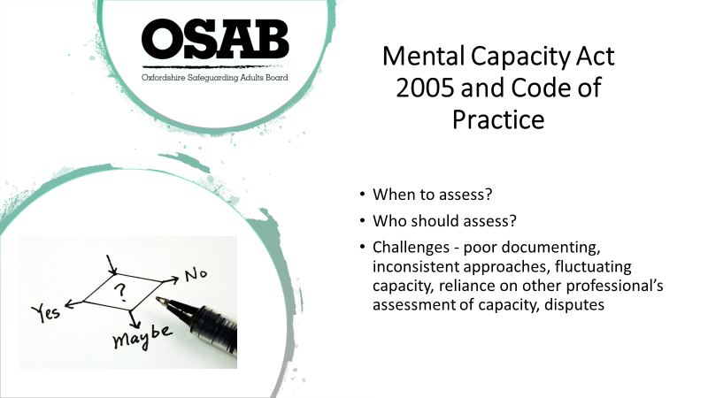

Trainers – this slide follows on nicely from the previous slide. It is designed to highlight some of the questions and difficulties that can arise in practice.

Team managers and leads should have a working understanding of the Mental Capacity Act 2005 and its principles, in order to offer guidance to staff. Some leads/managers will be able to assess mental capacity and partake in decision making discussions as to the Best Interests (BI) of individuals unable to make relevant decisions or know who to refer to make/assist in those decisions. Some leaders/managers will need to chair BI meetings.

When to assess? –

Where a person is unable to make a specific decision at a specific time because their mind or brain is affected by illness of disability.

Who should assess? –

- Anyone caring for or supporting a person who may lack capacity could be involved in assessing capacity – follow the two-stage test.
- The MCA is designed to empower those in health and social care to do capacity assessments themselves, rather than rely on expert testing by psychiatrists or psychologists – good professional training is key.
- However, in cases involving complex or major decisions, for example, person is unable to consent to medical treatment, you may need to get a professional opinion, for example, a general practitioner (GP) or a specialist (Clinical Oncologist).

Challenges that can arise –

- Poor documenting of capacity – what are you seeing that means you don’t believe they have capacity? “X does not have capacity” – is not a useful statement as it does not consider ‘decision specific and time specific’. It is a broad-brush statement that does not hold any weight. It would not stand up in Court!
- Inconsistent approaches – for example, a person who has been formally assessed as lacking capacity around the decision to sign for a loan, is then asked to sign for a loan. A further example could be a person being deemed to lack capacity around the decision to rent a flat and the responsibilities that come along with it, is asked to sign a tenancy agreement. This is where communication is key between agencies.
- Fluctuating capacity – a person may lose mental capacity because of a mental illness, brain injury, stroke, severe learning disability or through alcohol or drug use. The loss of capacity may be temporary. A person may be going through shock, may have an illness which sometimes gets worse and affects their ability to make decisions at certain times.
For example, if a person has bipolar disorder they may lack the capacity to make financial decisions whilst experiencing an episode of mania. The person may understand the information presented to them, be able to retain the information, but may not be able to weigh up the information in terms of considering the implications of, for example, spending all their money (bills go unpaid etc.).
- Reliance on other professionals’ assessments of capacity – When is someone else’s judgement ok to use?? NOTE Covert meds?!? Legal literacy. Challenging of others. You need to be confident in your own abilities to be able to feed into that (or you are the person doing that)
- Disputes - where there is a dispute that cannot be resolved between the professionals, the person and/or their relatives about what is in the person’s Best Interests, the matter should be referred to the Court of Protection for the decision to be made. The Court of Protection also has authority to make official decisions (called orders) about any healthcare, welfare or financial matters.

Trainers to hand out MCA booklets. They are a good aide memoir and are small enough to carry around.

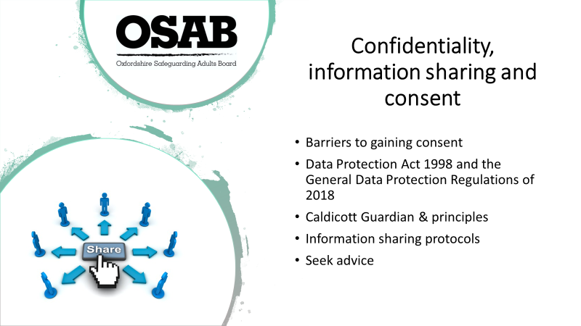

Barriers to gaining consent (to share information and engage with safeguarding response) – include issues of seeking or accessing help. For some communities, issues are expected to be dealt with internally without outside help and there have been examples where families have failed to seek appropriate support for disabled relatives as their religious leaders have deemed it a test of their faith or a punishment for a sin.

A person with previous experience of professionals, i.e. as a child, they may not trust social services or other partners, may be frightened of reprisals, may fear losing control, or may fear that their relationship with the abuser will be damaged.

If a person refuses intervention to support them with a safeguarding concern, or requests that information about them is not shared with other safeguarding partners, their wishes should be respected. However, there are a number of circumstances where the practitioner can reasonably override such a decision, including: lack of mental capacity to make that decision – this must be properly explored and recorded in line with the Mental Capacity Act, other people are, or may be, at risk, including children, sharing the information could prevent a crime, the alleged abuser has care and support needs and may also be at risk, a serious crime has been committed, staff are implicated, the person has the mental capacity to make that decision but they may be under duress or being coerced, the risk is unreasonably high and meets the criteria for a multi-agency risk assessment conference referral, a court order or other legal authority has requested the information. Keep a record of your decision and the reasons for it – whether it is to share
information or not. If you decide to share, then record what you have shared, with
whom and for what purpose.

The Data Protection Act 2018 (DPA) controls how a person’s personal information is used by organisations, businesses or the government.

The DPA is the UK's implementation of the General Data Protection Regulation (GDPR). Everyone responsible for using personal data must follow strict rules called 'data protection principles'. They must make sure any information is; used fairly, lawfully and transparently, used for specified, explicit purposes, used in a way that is adequate, relevant and limited to only what is necessary, accurate and, where necessary, kept up to date, kept for no longer than is necessary, handled in a way that ensures appropriate security, including protection against unlawful or unauthorised processing, access, loss, destruction or damage.

Caldicott Guardian & Principles – A Caldicott Guardian is a senior person responsible for protecting the confidentiality of people's health and care information and making sure it is used properly. The Caldicott Principles sets out six Principles that organisations should follow to ensure that information that can identify a patient is protected and only used when it is appropriate to do so. All NHS organisations and local authorities which provide social services must have a Caldicott Guardian and follow the 6 principles.

Within your own organisations you should have and be familiar with information sharing protocols.

If in doubt about sharing information, seek advice, and/or refer to your organisation’s written policies.

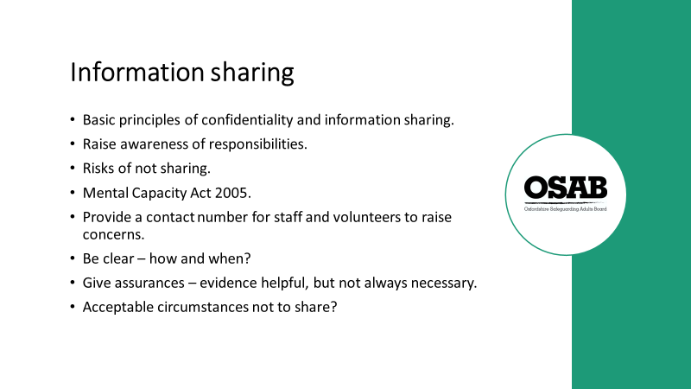

Staff can be over-cautious about sharing personal information, particularly if it is against the wishes of the individual concerned. They may also be mistaken about needing hard evidence or consent to share information.

As leads/managers you can assist your staff by:-

- Briefing staff and volunteers on the basic principles of confidentiality and data protection.
- Raising awareness about responsibilities to share information (profession, or work role specific guidance may help).
- Encouraging consideration of the risks of not sharing information. The risk of sharing information is often perceived as higher than it is. It is important that staff consider the risks of not sharing safeguarding information when making decisions. Many Safeguarding Adult Reviews have highlighted the lack of information sharing/poor communication between partners who did not take a joined-up approach to safeguarding people, have been a factor which eventually led to the outcome.
- Improving understanding of your staff team of the principles of the Mental Capacity Act 2005.
- Providing a contact number for staff and volunteers to raise concerns and have discussions – for when you are available/unavailable.
- Be clear in procedures about how and when to share information/raise a safeguarding concern.
- Assure staff and volunteers that they do not necessarily need to have ‘hard evidence’ to raise a concern.

Given the duty to cooperate in the Care Act 2014, there are only a limited number of circumstances in which it would be acceptable not to share information pertinent to safeguarding with relevant multi-agency safeguarding partners. These would be where the person involved has

the mental capacity to make the decision in question and does not want their information shared, and:

• their 'vital interests' do not need to be protected. Vital interests are intended to cover only interests that are essential for someone's life. So, this lawful basis is very limited in its scope, and generally only applies to matters of life and death.
• nobody else is at risk
• there is no wider public interest
• no serious crime has been or may be committed
• the alleged abuser has no care and support needs
• no staff are implicated
• no coercion or duress is suspected
• the risk is not high enough to warrant a referral to a Multi-Agency Risk Assessment Conference (MARAC)
• no other legal authority has requested the information.

It is worth bearing in mind that the Data Protection Act 1998 and the General Data Protection Regulations of 2018 permit information to be shared in a situation of ‘vital interest’, where it is critical to prevent serious harm or distress or where someone’s life is threatened. However, if the only person who would suffer if the information is not shared is the subject of that information, and they have mental capacity to make a decision about it, then sharing it may not be justified.

If there is continued reluctance from one partner to share information on a safeguarding concern, or in instances where an alerting organisation thinks that the local authority response is not sufficient, then the matter should be referred to the Safeguarding Adults Board (SAB). The SAB should discuss the issue, including the organisation's stated reasons for not sharing the information. The SAB will decide what course of action to take.

The SAB can also consider whether the concern warrants a request, under Section 45 of the Care Act 2014, for the ‘supply of information’.

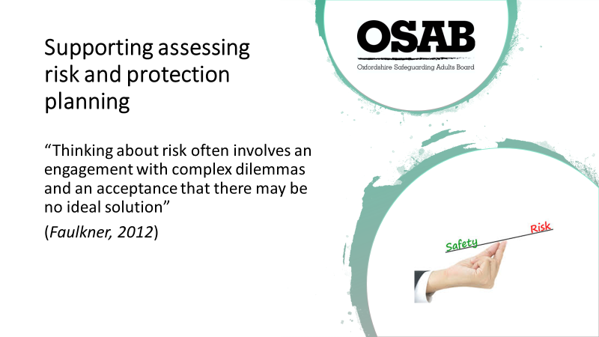

This slide is designed to highlight the complexities which can arise in safeguarding situations.

The purpose of risk assessment is to establish the likelihood and the impact of any actual or potential harm.

It is important to recognise that risk is a normal everyday experience and that therefore the
Safeguarding Principles must be applied in a manner that promotes empowerment and proportionality as well as prevention. Context is important!

The assessment of risk must consider the harm that has previously occurred, as this will assist in establishing facts and the impact of the hazard. More important is the assessment of the future potential for harm, which will be informed by, but is not dependent on history.

Risk assessments must recognise and acknowledge the protective factors that may be
in place and which are already mitigating the potential harm of a situation.

Risk assessment should focus on the desired outcomes of the adult and others and, in
recognition of the fact that life is never free from risk, desired outcomes need to be
compared against other potential consequences.

The assessment and management of risk (protection planning) is primarily the responsibility of the adult unless it is the case that they are unable to make the relevant decisions or are so intimidated or controlled by others that they are unable to protect themselves. (Empowerment – the first Principle of the Six Principles in Safeguarding Adults)

Professional staff have the responsibility to reach their own assessment of the potential risk of harm and this is a continuous process. The purpose of identifying the harm and the likelihood is to determine whether any intervention (protection planning) is necessary and, if so, what is the most appropriate course of action.

Risk assessments should include -
Clear assessment of actual and/or perceived risk.
Be factual and as objective as possible.
Be proportionate. Use necessary information. Be as succinct as possible.
Involve the person and capture their views.
Use your specialist/professional knowledge i.e. best practice in cases of self-neglect etc.
Use plain English. Avoid acronyms
Include any associated issues/conditions which increase risk, i.e. physical, psychological, social, mental, etc.

Where role includes conducting detailed assessments of adults at risk of harm or abuse, professionals must be able to apply in depth knowledge of safeguarding issues in the assessment and examination of the adult at risk and how to provide reports with an opinion.

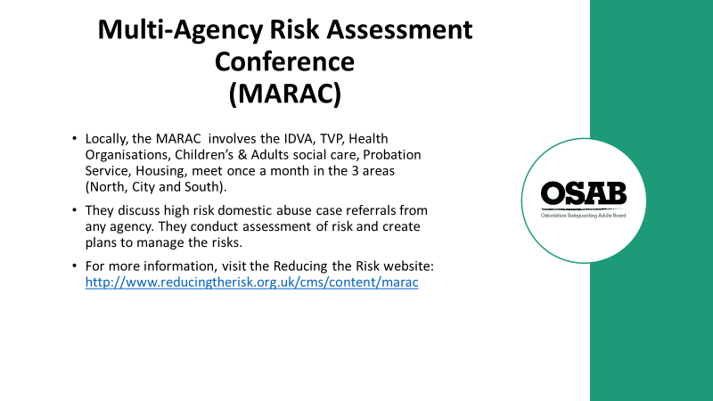

Leads should have an understanding of and ability to make appropriate referrals to MARAC.

How do people find who the Designated MARAC Officer (DMO) is within their organisation and what is the referral mechanism if they do not have a DMO?

The formal risk assessment Domestic Abuse Stalking Harassment and Honour Based Violence (DASH) risk assessment (alternatively known as a DOM5 which is the Police force’s version) would be carried out prior to a referral to MARAC. Further risk assessment around other risk factors may be carried out by MARAC.

The DASH should be used whenever a professional receives an initial disclosure of domestic abuse. It is designed to be used for those suffering current rather than historic domestic abuse and, ideally, should be used as a rapid response to an incident of abuse. Risk in domestic abuse situations is dynamic and can change very quickly. As and when things change the risk assessment must be re-visited and reviewed.

CAADA (now called Safe Lives) recommend that a threshold of 14 ticks or above is a defensible position to take when referring a case to MARAC.

A Multi Agency Risk Assessment Conference (MARAC) is a victim focused information sharing and risk management meeting attended by all key agencies, where high risk domestic abuse cases are discussed. It is a professional’s meeting only.

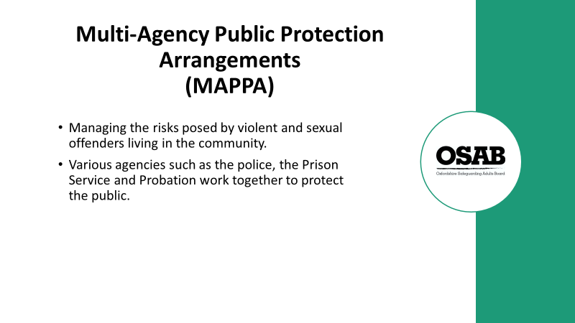

What is the aim of MAPPA?

The aim of MAPPA is to manage the risks that violent and sexual offenders pose to the public by managing the risks associated with these categories of offenders.

The various agencies share information about offenders under MAPPA in order to assess the level of risk they pose to the public.

MAPPA allows agencies to assess and manage offenders on a multi-agency basis by working together, sharing information and meeting as necessary to ensure that effective plans are put in place.

Who is placed under MAPPA?

There are three categories of MAPPA offenders:

Category One – All registered sexual offenders. Registered sexual offenders are required to notify the police of their name, address and personal details under the terms of the Sexual Offences Act 2003.

Category Two – Violent or other sex offenders not subject to notification requirements, including violent offenders who have been sentenced to 12 months or more, or to detention in hospital, and who are now living in the community subject to Probation supervision.

Category Three – Other dangerous offenders who have committed an offence in the past and who are considered to pose a risk of serious harm to the public.

All information taken from NACRO website ‘Advice for people under MAPPA’ https://www.nacro.org.uk/resettlement-advice-service/support-for-individuals/advice-prisoners-people-licence-sex-offenders-mappa/advice-people-mappa/

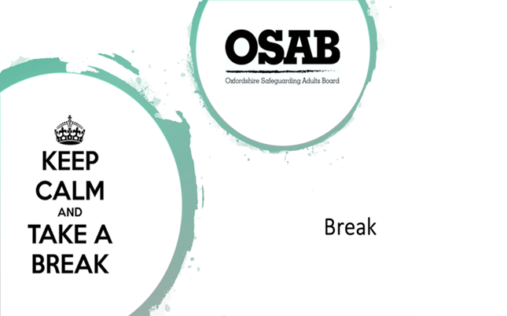

10 minute break (can be a little longer if time allows).

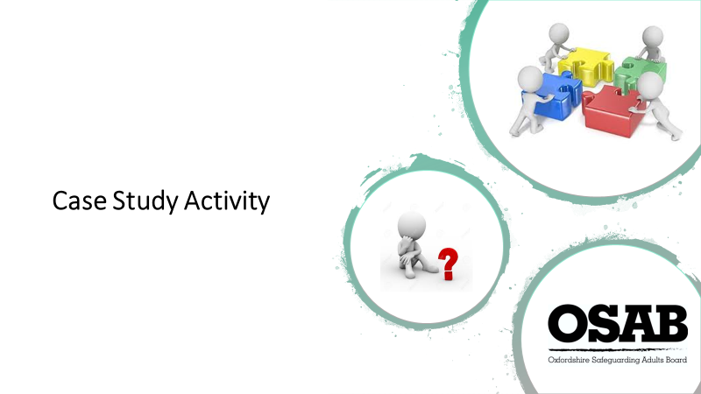

The case study is divided into two parts. Trainers to hand out Part 1 initially (along with a copy of the Threshold of Needs Matrix for each attendee). Trainers to ask attendees in groups to consider the information contained and questions posed. Give 5-10 minutes for discussion, then seek feedback from the groups.

Next, hand out Part 2, again asking attendees in groups to consider the information contained and questions posed. Give 10-15 minutes for discussion, then seek feedback from the groups.

Following discussion, Trainers are to explain the case study is based on a real life example (some information has been changed to help protect identities) In terms of work undertaken and outcomes, please see below…

J’s initial expressed outcomes (in terms of the safeguarding enquiry) were to carry on with his current lifestyle. He wanted to continue living where he was and was likely to continue his relationship with partner.

Early information came in that both J and his partner B signed disclaimers with the Police that they didn’t want to take action when the Police had been called to J’s property due to domestic violence concerns. On each occasion both J and B were intoxicated by alcohol.

A DASH risk assessment was completed. The risks were assessed as high, so J and his partner were referred to MARAC and a referral was made to the Independent Domestic Violence Advocacy service for J to gain support from an IDVA.

J was starting to engage with the IDVA, had an assessment of his needs completed by Adult Social Care. Alternative housing was being sought for him (with his agreement).

There was a Domestic Violence Protection Order put in place which restricted B’s ability to go within a certain area of J.

Whilst safeguarding work was being undertaken, the Police were called and J was found dead in his partner’s home. He died from a head injury. There were concerns that B may have been involved in his death, but there was not enough evidence to bring about a prosecution case, so the charges against B were dropped.

This case brings up questions around; capacity when intoxicated and subsequent ability to make a decision about signing disclaimers. Also, coercive control in relationships and how that can affect a person’s decision-making ability. Along with other issues!

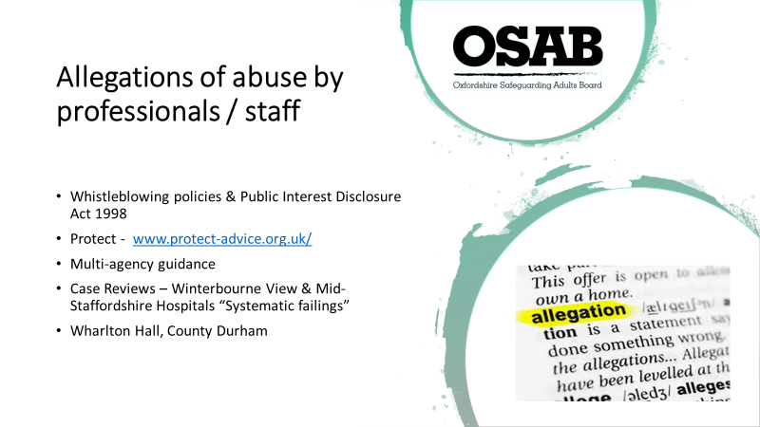
This slide is designed to reflect on the fact that at times, safeguarding concerns are raised about professionals/staff/people in a position of power.

All organisations should have whistleblowing policies and leads/managers should ensure staff are aware of them, their purpose, and how to whistle-blow if needed. Staff also need to follow guidelines from their professional body (if registered). Policies may be referred to as ‘speaking up’ or ‘raising concerns in the workplace’ but it all has the same meaning.

Concerns should be raised within an organisation/company initially, but if that is not possible, employees can contact Protect (website address on slide). Protect is an independent organisation which provides free legal advice to employees who are worried about malpractice at work.

Public Interest Disclosure Act 1998 - The Act protects most workers in the public, private and voluntary sectors. The Act does not apply to genuinely self-employed professionals (other than in the NHS), voluntary workers (including charity trustees and charity volunteers) or the intelligence services. It is designed to protect workers from detrimental treatment or victimisation from their employer if, in the public interest, they blow the whistle on wrongdoing. Further reading – https://www.gov.uk/government/publications/the-public-interest-disclosure-act/the-public-interest-disclosure-act

Multi-agency guidance – On the OSAB website there is a procedure which provides a framework for all agencies working in Oxfordshire when managing allegations against staff or volunteers. The scope of the procedure is not limited to allegations involving significant harm or risk of significant harm to an adult with care and support needs.
Further reading -
https://www.osab.co.uk/wp-content/uploads/Allegations-against-staff-v6-dated-feb-18.pdf

Case Reviews

Serious Case Reviews (now Safeguarding Adult Reviews since the Care Act 2014 came into force) seek to determine what relevant agencies and individuals involved could have done differently that could have prevented harm or a death from taking place.

There are many that take place nationally, two of which are highlighted on the slide:-

Winterbourne View – One of the main points picked up from the Department of Health review was “Multiple agencies failed to pick up on key warning signs – nearly 150 separate incidents – including A&E visits by patients, police attendance at the hospital, and safeguarding concerns reported to the local council – which could and should have raised the alarm”

Further reading – Winterbourne

Department of Health review
https://assets.publishing.service.gov.uk/government/uploads/system/uploads/attachment_data/file/213215/final-report.pdf

South Gloucestershire Safeguarding Adults Board Serious Case Review
http://sites.southglos.gov.uk/safeguarding/adults/i-am-a-carerrelative/winterbourne-view/

Mid-Staffordshire hospitals - systematic failures of care at multiple levels, including:
• perceived problems were too often assumed to be the responsibility of others
• institutional culture that cared more about the needs of the hospital staff than the patients
• unacceptable willingness to tolerate poor standards of patient care
• failure to accept and respond to legitimate complaints
• failure of different teams within the hospital, as well as in the wider community, to communicate
and share their concerns
• failure of leadership – in particular, financial changes needed to achieve Foundation Trust status
were seen, by the inquiry, to take precedence over patient care

Further reading – Mid Staffordshire

Report of the Mid Staffordshire NHS Foundation Trust Public Inquiry
http://www.hampshiresab.org.uk/learning-from-experience-database/serious-case-reviews/location/mid-staffordshire/

PLAY YOUTUBE CLIP re: Whorlton Hall

Please warn attendees that the video has some images that they may find distressing
Show Video – Whorlton Hall – BBC coverage https://www.youtube.com/watch?v=bkjL_fLILXk
– clip runs for 2 minutes 55 seconds.

After the clip has ended it is useful to highlight the last statement in the clip “with more than a hundred visits by official agencies to Whorlton Hall within the past year, many will question how this abuse could have been missed?”

A Care Quality Commission (CQC) inspection was undertaken in 2015, rated the service ‘requires improvement’. This report was not published. A further report undertaken a year later, and undertaken by a different CQC Inspector, deemed the service as ‘good’. This report was published.

If abuse or neglect takes place in a service such as a care home, home care agency, day centre, hospital or college, the first responsibility to act lies with the employing organisation as the provider of the service. When an employer or manager is aware of abuse or neglect happening in their organisation, they should do two things:
- inform the local authority (and the local clinical commissioning group, if the NHS is the commissioner), taking into account the person’s wishes
- take action to protect the adult concerned from further harm (such as by removing the staff or volunteers involved, or by providing them with additional training or supervision).

The employer (a term also used here to cover managers in places where there is no employer, such as in a volunteer-run service) should carry out their own initial investigation of any safeguarding concern. This should happen unless there is a compelling reason why it is thought to be inappropriate or unsafe, for example:

- there is a serious conflict of interest (such as a small, family-run home where a wife might be investigating her husband)
- there is reason to believe that the matter will not be responded to effectively (such as in a small or volunteer-led body where there isn’t sufficient expertise or experience) or
- there is a reasonable suspicion that a criminal offence has taken place.

When a manager or other care provider in a position of responsibility does not ensure that the appropriate care, environment or services are provided to maintain the health and safety of adults at risk in their care, then they may be open to a charge of "Wilful Neglect".

The offence of 'wilful neglect' is an offence under the Criminal Justice and Courts Act 2015 (CJCA 2015) under which there is criminal liability where a person has been placed under the care of a medical professional in a hospital or care home (s 20), or under private home care (s21).

The offences contrary to sections 20 and 21 of the Criminal Justice and Courts Act 2015 are a part of the Government's response to the public inquiry conducted by Sir Robert Francis QC into the events at Mid-Staffordshire NHS Foundation Trust.

There are already offences in respect of the ill-treatment and wilful neglect of patients receiving treatment for mental disorder (s.127 Mental Health Act 1983) and of those who lack capacity under the Mental Capacity Act 2005 (s.44 Mental Capacity Act). However, there is no equivalent specific offence in relation to those being cared for with full capacity. The offences contrary to sections 20 to 25 of the Criminal Justice and Courts Act 2015 close this gap in existing legislation.

Further reading - https://www.cps.gov.uk/legal-guidance/ill-treatment-or-wilful-neglect-offences-sections-20-25-criminal-justice-and-courts

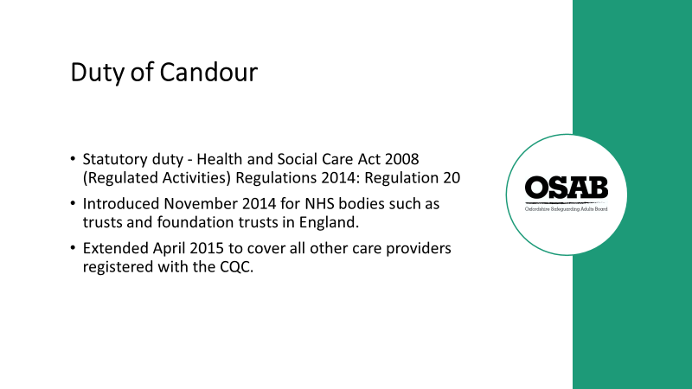

The Duty of Candour is a statutory duty to be open and honest with people and/or their families, when something goes wrong that appears to have caused or could lead to significant harm in the future, generally in relation to care and treatment, including informing people about the incident, providing reasonable support, providing truthful information and an apology when things go wrong.

The regulation applies to registered persons when they are carrying on a regulated activity.

CQC can prosecute for a breach of parts 20(2)(a) and 20(3) of this regulation and can move directly to prosecution without first serving a Warning Notice. Additionally, CQC may also take other regulatory action.

Further reading https://www.cqc.org.uk/guidance-providers/regulations-enforcement/regulation-20-duty-candour

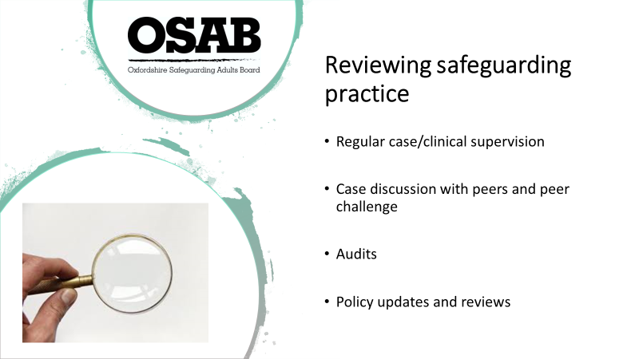

All points on the slide are constructive and should be used as tools for learning what is done well and where improvements can be made. They allow Leads/Managers to check internal and multi-agency procedures are being followed and are effective. They also ensure everyone is working within the remit of their roles and within the boundaries of the law.

Inspection processes are a further way of checking/ensuring organisations/services are following best practice.

Case/clinical supervision - Leads/Managers are responsible for the standard of safeguarding practice within their team. They should make sure that supervision is used as an opportunity to challenge practice constructively, and to identify any barriers to effective practice – not simply to check compliance with procedures. Sessions may be one-to-one or in groups.

While supervision sessions should be flexible enough to allow supervisees to raise the issues they are most immediately concerned about, it might be useful to have safeguarding as a constant agenda item at every session, so that Leads/Managers can be assured that staff are handling any potential safeguarding situations appropriately.

Case discussion with peers and peer challenge - Leads/Managers should encourage reflective, critical thinking about safeguarding practice with specific people and situations. Encourage staff to discuss people’s situations and seek support from their peers. Peers should also be enabled to constructively challenge any areas of poor attitudes or practice.

Audits – Organisations/companies are likely to have their own internal audit processes which should identify how well, or otherwise, their safeguarding practice is. Oxfordshire Safeguarding Adults Board hold audits of all partners and their safeguarding practice. OSAB oversee the implementation of any resulting recommendations and action plans from the audits.

Policy update and reviews – Leads/Managers may be involved in writing, reviewing and updating internal safeguarding policies. Up to date knowledge of adult safeguarding is therefore essential.

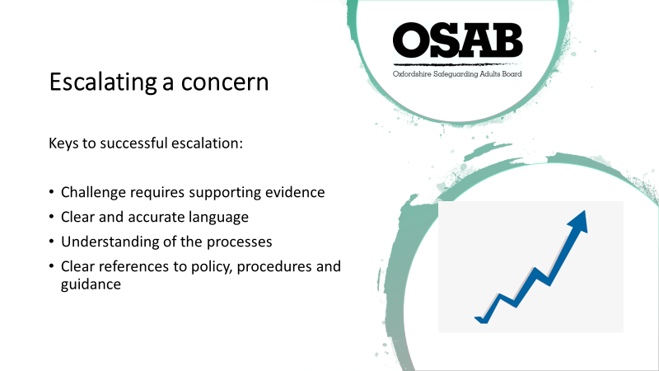

The previous slide concentrated on reviewing safeguarding practice within your own organisation/company. Now we consider what Leads/Managers may need to do when receiving concerns from staff about responses from other organisations/agencies.

Professionals must be able to escalate concerns where they believe a situation has not been dealt with correctly. There can be many inconsistencies which need to be challenged.

It may be the concern was sent by your service/organisation to the Adult Safeguarding Service who concluded it did not meet the threshold to go further to a S42 enquiry. If this was the case and you did not agree with the outcome, you should refer to a Practice Supervisor in the team initially (duty/triage stage). Talk to the person that’s been involved (enquiry stage). If you can’t resolve, then their supervisor.

The points on the slide emphasise the importance of understanding processes and the responsibilities of different organisations/companies/agencies.

Use of supporting evidence is always useful as it may be not all relevant information that should have been shared at the time, was.

We are all human and are not always going to get it right?! It should not be a ‘them’ and ‘us’ culture when working alongside other agencies/companies/organisations. At the end of the day we are all working with the individual at the centre.

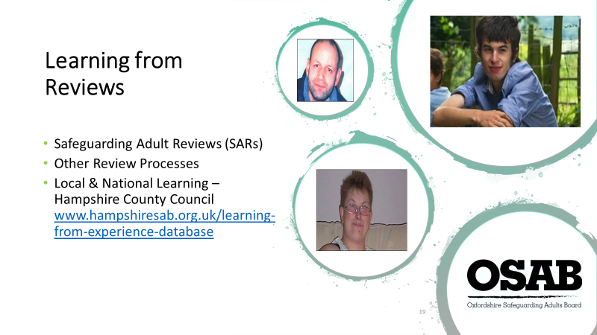

All Safeguarding Adults Boards have a statutory responsibility for commissioning and undertaking Safeguarding Adults Reviews (SARs) under Section 44 of the Care Act 2014.

Safeguarding Adults Review (SAR) - is commissioned when there has been the death of serious injury of an adult with care and support needs and there are concerns about how organisations worked together to protect the adult. The SAR seeks to determine what relevant agencies and individuals involved could have done differently that could have prevented harm or a death from taking place.

The photographs on the slide are of people who are deceased, and have been the subject of SAR’s and Independent Reviews.

The purpose of a SAR is to:

- look at any lessons we can learn from the case about the way all local professionals and agencies worked together
- review the effectiveness of safeguarding adult policies and protocols
- inform and improve local safeguarding practice for all agencies involved
- deliver an overview report and recommendations for future action

The reviews are not about apportioning blame.

OTHER REVIEWS:

Trainers to focus on the following two review processes, but there are more!

Domestic Homicide Reviews (DHR) - are carried out to ensure that lessons are learnt when a person has been killed as a result of domestic violence. The Home Office multi-agency statutory guidance defines a Domestic Homicide Review as a review of the circumstances in which the death of a person aged 16 or over, has or appears to have resulted from violence, abuse or neglect by:
- a person whom he/she was related or had been in an intimate personal relationship, or
- a member of the same household

The purpose of a Domestic Homicide Review is to:
- Establish what lessons are to be learned from the domestic homicide regarding the way in which local professionals and organisations work individually and together to safeguard victims
- Identify clearly what those lessons are both within and between agencies, how and within what timescales they will be acted on, and what is expected to change as a result
- Apply those lessons to service responses including changes to policies and procedures as appropriate
- Prevent domestic violence homicide and improve service responses for all domestic violence victims and their children through improved intra and inter-agency working

MAPPA Serious Case Review (MAPPA SCR) – is a process managed by the Strategic Management Board (SMB). It is a Strategic Management Board ("SMB") responsibility to commission a MAPPA SCR when the mandatory criteria have been met. MAPPA SMB is the means by which the Responsible Authority fulfils its duties under section 326 (1) of the Criminal Justice Act 2003 to:

‘Keep the arrangements (i.e. MAPPA) under review with a view to monitoring their effectiveness and making any changes to them that appear necessary or expedient.’

The SMB must commission a MAPPA SCR if both of the following conditions apply.
- The MAPPA offender (in any category) was being managed at level 2 or 3 when the offence was committed or at any time in the 28 days before the offence was committed.
- The offence is murder, attempted murder, manslaughter, rape, or attempted rape.

Local and National Learning - Applying lessons from Safeguarding Adults Reviews /case management reviews to improve practice. Hampshire Safeguarding Adults Board have a database of Serious Case Reviews (which we in place prior to the implementation of the Care Act 2014) and Safeguarding Adult Reviews around the country. Searches can be made via Theme, Local Authority Area or Year. The Safeguarding Adult Reviews are held by SCIE and can be accessed via the Hampshire website.

They Key lessons that have arisen out of SAR’s to date:

Abuse wasn’t recognised or understood
Concerns weren’t documented or shared
Poor standards of care were unchallenged
Vulnerabilities weren’t recognised
Lack of professional curiosity
Lack of joint working across agencies
Lack of legal literacy

We should be mindful of these lesson and use best practice to avoid such findings occurring again.

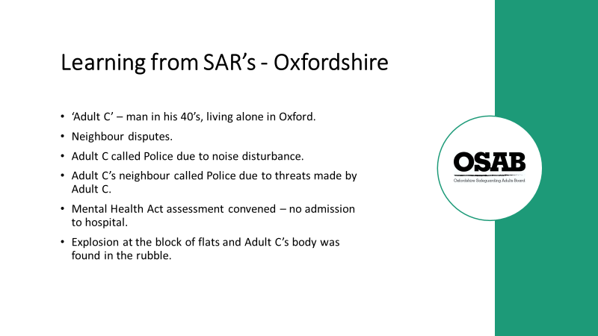

Trainers to acknowledge that the points on the slide do not cover all the relevant information. They are designed to give a brief overview.

Adult C was involved in a number of disputes with a neighbour (noise) and was arrested on several occasions for aggressive and threatening behaviour.

Following Adult C’s call to Police to make the noise disturbance complaint, the call handler was concerned due to Adult C’s speech being bizarre and thought Adult C may have mental health issues.

Police were called at the same time by a concerned neighbour reporting that Adult C had threatened to set fire to the flat the previous night and had taken two cans of petrol inside.
Police officers visited the property soon afterwards, forced entry and called an Ambulance because of concerns for Adult C's mental state.

The following morning a Mental Health Act assessment was convened, which concluded Adult C did not require admission to hospital, but community follow-up was arranged via the Step-Up Team, and Adult C had face-to-face and telephone contact with staff over the next two days.

Four days after Police attended, there was an explosion at the flats and Adult C’s body was found in the rubble.

This SAR was published in April 2018.

The SAR concluded:

- If the fire was accidental it could not have been reasonably predicted or prevented.
- If the fire was deliberate, there was still no clear evidence that is was predictable or preventable.
- The Review found mental health services were of good professional standard, and the system for convening and undertaking and emergency MHA assessment worked well.

Learning outcomes for the NHS, TVP and Housing Provider (A2Dominion) were highlighted.

Further reading: https://www.osab.co.uk/wp-content/uploads/SAR-Adult-C-Full-Report-published-version.pdf

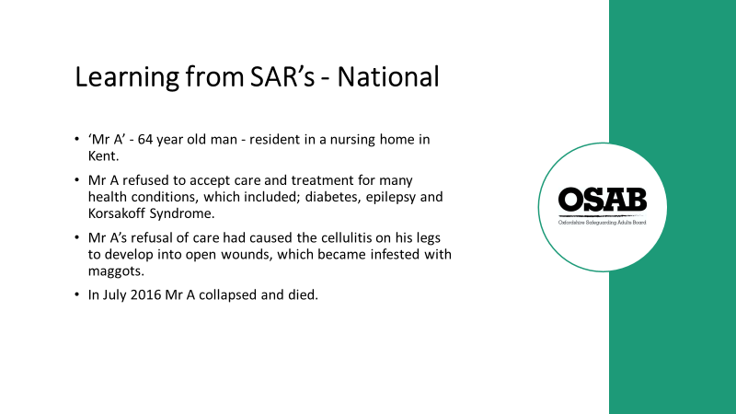

Mr A was a 64-year-old man who was a resident in a nursing home in Kent.

He refused to accept care and treatment (sometimes aggressively) for many health conditions, which included; diabetes, epilepsy and Korsakoff Syndrome (a chronic memory disorder commonly caused by alcohol misuse). His refusal to accept treatment led to festering leg wounds that became infested with maggots during the final days of his life.

Mr A first entered nursing care in 2013 but after being admitted to Maidstone Hospital for leg ulcer treatment, the home refused to take him back because they felt unable to cope with his behaviour. The hospital spent nearly two weeks trying to find a home within Kent to accept him without success.

A friend to whom Mr A had given lasting power of attorney over his welfare and property, agreed to what was meant to be a short-term placement at an East Sussex nursing home.

Mr A wanted to stay in Kent but a mental capacity assessment carried out at the hospital concluded that while he had capacity to make decisions about medical treatment, he lacked capacity in regards to his discharge to East Sussex and the move was in his best interests.

In East Sussex Mr A continued to regularly refuse treatment and care despite repeated attempts to convey the dangers to his life that entailed.

The safeguarding adults review found that opportunities were missed to address Mr A’s mental health and its impact on his physical health. Issues included a lack of recorded mental capacity assessments, not pursuing the option of detention under the Mental Health Act and missed opportunities to seek clarification on Mr A from the Court of Protection (lack of legal literacy)!

This SAR was published in June 2017.

Further reading: https://www.eastsussexsab.org.uk/wp-content/uploads/2017/10/Adult-A-SAR-Final-Version-3.pdf

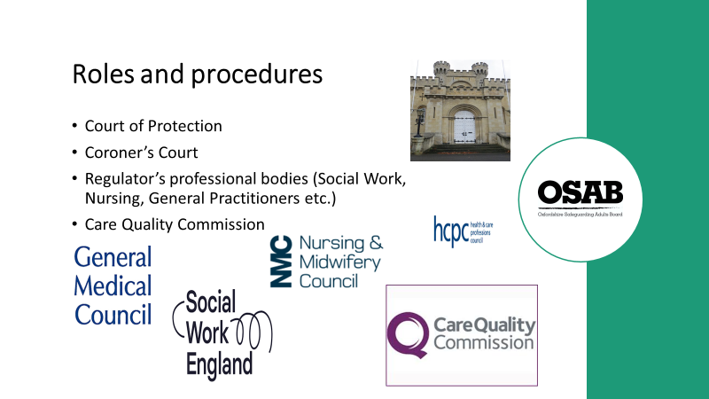

Unfortunately, as we’ve just considered during the last few slides, work can be undertaken to support individuals, but people are still harmed and/or die as a result of the abuse or neglect they experience. This slide highlights the role of the Courts and regulatory bodies.

Court of Protection - The Court of Protection is of great importance as it exists to safeguard people with vulnerabilities who lack the mental capacity to make decisions for themselves. These decisions may relate to the person's finances or their health and welfare. The CoP is responsible for determining disputes as to the registration of Lasting Powers of Attorney, appointing new trustees, appointing deputies to manage the affairs of persons who do not have the mental capacity to make the relevant decisions. The COP investigate any claims against registered Attorneys.

Coroner’s Court – You may be called as a witness to an Inquest. You may have already provided statements to any internal inquiry. Your witness statement will go to the Coroner’s Court prior to the inquest. The inquest is an inquiry to establish who the deceased was, when they died, where they died and how they came by their death. “How” can include the cause of death and the immediate events and circumstances that led to the death. On occasions, but only rarely, the inquest can also include an investigation into the wider circumstances including systems and procedures which may have contributed to the death.

Trainers to highlight this recent case…
A care home consultant was sentenced to four months’ custody for withholding evidence/ documentation from an inquest into the death of a young care home resident (31.10.2019)
https://www.weightmans.com/insights/prison-for-care-home-consultant/?utm_source=email&utm_medium=email&utm_campaign=LU%20%20Prison%20for%20care%20home%20&lsquo%3Bconsultant&rsquo%3B

There are other bodies that are designed to safeguard adult we work with, and for us as professionals:-

Regulator’s professional bodies – Are responsible for registering all professionals (that come under their jurisdiction), ensuring they carry out continuing professional development, regulating education providers and handling fitness to practice concerns.

Care Quality Commission - Register, monitor, inspect and regulate services to make sure they provide people with safe, effective, compassionate, high quality care. Intervene and take regulatory action on breaches. Publish findings including performance ratings.

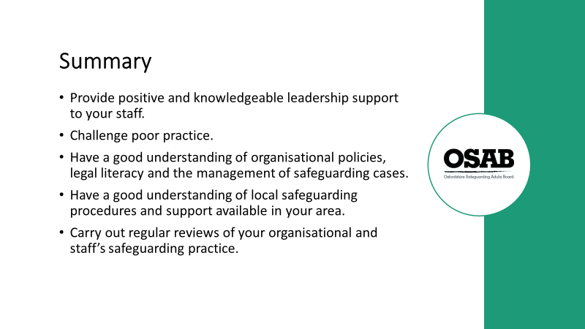

This slide is to be read out as a summary in terms of what has been covered during the session. It is to be read with Trainers offering a brief recap if certain points were highlighted by specific points/questions during the session, in order to bring conclude the session.

Please check that everyone has signed the register. Inform attendees that they need to log into their OSAB account to complete an evaluation form. Once completed, they will then have the opportunity to download their Certificate of Attendance.

END OF SESSION

And finally…

THANK YOU for being a Trainer for Oxfordshire Safeguarding Adults Board. I hope the delivery of sessions go well and they are enjoyable experiences for you.

Regards,

Helen Kershaw
Learning & Engagement Officer,
Oxfordshire Safeguarding Adults Board

